**SHARE**

**H2020 NFRP-2018 CSA: Coordination and Support Action**

**Grant Agreement n° 847626**

**D2.5: Matrix and explanatory report from Task 2.3**

**Author: [Federica Pancotti SOGIN, Rossella Sciacqua SOGIN]**

**With contributions from: [Gintautas Poškas LEI, Laura Aldave de las Heras JRC, Christine Georges CEA, Muhammad Junaid Ejaz Chaudhry KIT, Reka Szoke IFE, Jorge Borque Liñán ENRESA]**

**Reviewers: [Emilio Garcia Neri ENRESA, Christine Georges CEA]**



|  |  |
| --- | --- |
| **Deliverable nature** | Report |
| **Dissemination level** | Public |
| **Contractual delivery date** | 26.02.2021 |
| **Actual delivery** | 28.05.2021 |
| **Version** | V2 |

**Version history**

|  |  |  |  |
| --- | --- | --- | --- |
| **Version** | **Date** | **Editors** | **Description** |
| V1 | 14.04.2021 | F. Pancotti, R. Sciacqua | Writing of the deliverable |
| V2 | 14.05.2021 | F. Pancotti, R. Sciacqua | New version after comments from Reviewers |
|  |  |  |  |

# Deliverable content

Deliverable content 3

Abstract 5

Abbreviations 6

List of figures 7

List of tables 9

1 Introduction 10

2 Methodology for identifying the Weighting Factors 11

2.1 Total Population Contacted and Population answering the Survey 12

2.2 Weighting Factors identification and assignment 14

2.2.1 Stakeholders’ Types 15

2.2.2 Status of Decommissioning project 21

2.2.3 Region 23

2.2.4 Final Weighting Factors 25

2.3 Weighted Matrix 26

2.3.1 Weighted-Population Survey 26

2.3.2 Weighted-All Survey 26

3 Weighted Analysis results – Identification of priorities 27

3.1 Global Survey Results 28

3.1.1 General thematic areas 28

3.1.2 Sub-thematic areas 29

3.2 Analysis of priorities by Region & Country 37

3.2.1 General Thematic Areas 38

3.2.2 Sub-thematic Areas 40

3.3 Analysis of priorities by Type of Organisation 45

3.3.1 General Thematic Areas 45

3.3.2 Sub-thematic Areas 48

3.4 Analysis of priorities by Status of Decommissioning Project 54

3.4.1 General Thematic Areas 54

3.4.2 Sub-thematic Areas 57

3.5 Analysis of priorities by Type of Facility 61

3.5.1 General Thematic Areas 61

3.5.2 Sub-thematic Areas 64

4 Weighted Analysis Conclusions 68

ANNEX I – Additional Graphs 79

ANNEX II – Completed working file 89

ANNEX III – Ranking of sub-thematic areas 97

# Abstract

The main goal of Task 2.3 is to produce an impartial, balanced and reliable assessment of the opinions collected during the SHARE survey, and to rank the needs for research in terms of importance and urgency in the identified thematic and sub-thematic areas.

The weighted analysis of the SHARE survey is based on the output of Sub-task 2.2.1 and 2.2.2.

The methodology was developed by SOGIN together with the JRC as leader of WP1 and for each weighting factor assessment, a committee of decision-makers was formed. It included SHARE WP2 Partners: ENRESA, CEA, IFE, JRC, KIT, LEI and SOGIN who are considered to have an appropriate background for the evaluation and represent different types of stakeholders.

The deliverable consists of 2 main Sections and three Annexes:

* Section 2 “Methodology for identifying the Weighting Factors” is dedicated to the description of the parameters and criteria used to define and assign the weighting factors
* Section 3 “Weighted Analysis results – identification of priorities” is dedicated to the assessment on the opinions collected and to the ranking of the needs for research in the thematic and sub-thematic areas. The analysis is performed on the global survey results and on the sorted data by Region & Country, Type of Organisation, Status of Decommissioning project and Type of Facility
* Annex I includes additional graphs that can be used for a comprehensive view of the overall Survey data
* Annex II includes the filled working files used for the Weighting factors assignment and assessment
* Annex III includes the full tables with the ranking of the sub-thematic areas in terms of importance and urgency in the Weighted Population and Weighted All Survey.

# Abbreviations

|  |  |
| --- | --- |
| PC | Total Population Contacted |
| PS | Population answering the Survey |
| WMO | Waste Management Organisation |
| TSO | Technical Support Organisation |
| SO | Standardisation Organisation |
| Non-EU | European countries that are not members of the EU |
| IO | International Organisation |
|  |  |
|  |  |

# List of figures

Figure 2‑1. Percentage of different Type of Stakeholders for the Total Population Contacted (left) and the Population answering the Survey (right) 13

Figure 2‑2. Type of Stakeholders: survey answers 15

Figure 2‑3. Instruction for filling the pairwise comparison matrix 16

Figure 2‑4. Pairwise comparison matrix 17

Figure 2‑5. Verification Matrix for Transitivity 17

Figure 2‑6. Approximated method for normalised eigenvector computation 18

Figure 2‑7. Status of Decommissioning project: survey answers 21

Figure 2‑8. Working file for the DELPHI method evaluation 22

Figure 2‑9. Region coverage 23

Figure 2‑10. Responses by region 23

Figure 3‑1. Weighted-Population and Weighted-All _ Importance and Urgency comparison – General thematic areas 29

Figure 3‑2. Global Survey full visualisation - Weighted-Population (left) and Weighted-All (right) – sub-thematic areas 34

Figure 3‑3. Weighted-Population and Weighted-All Importance and Urgency –Technical and Non-technical sub-thematic areas 35

Figure 3‑4. Weighted-Population and Weighted-All importance/Urgency comparison – Top 15 sub-thematic areas 36

Figure 3‑5. Number of Respondents by Country 37

Figure 3‑6. Countries in Weighted-Population (left) and Weighted-All (right) – General-thematic areas 39

Figure 3‑7. Sub-Thematic Weighted-Population (top) and Weighted All (bottom) data for Importance (left) and Urgency (right) _ sorted by Country 41

Figure 3‑8. Weighted-Population (left) and Weighted-All (right) _ Top 15 _ Country 43

Figure 3‑9. Weighted-Population (left) and Weighted-All (right) _ common Importance Priorities among the top 15 top priorities _ Country 44

Figure 3‑10. Number of Respondents by Type of Organisation 45

Figure 3‑11. Weighted Population - Weighted All comparison for general thematic areas. Type of Organisation. 46

Figure 3‑12. Type of Organisation in Weighted-Population (left) and Weighted-All (right) – General-thematic areas 47

Figure 3‑13. Sub-Thematic Weighted-Population (top) and Weighted All (bottom) data for Importance (left) and Urgency (right) _ sorted by Type of Organisation 49

Figure 3‑14. Weighted-Population (left) and Weighted-All (right) _ Top 15 _ Type of Organisation 52

Figure 3‑15. Weighted-Population (left) and Weighted-All (right) _ common Importance Priorities among the top 15 top priorities _ Type of Organisation 53

Figure 3‑16. Percentage of Respondents per Status of decommissioning project 54

Figure 3‑17. Weighted Population - Weighted All comparison for general thematic areas. Status of decommissioning. 55

Figure 3‑18. Status of decommissioning in Weighted-Population (left) and Weighted-All (right) – General-thematic areas 56

Figure 3‑19. Weighted-Population (left) and Weighted-All (right) _ Top 15 _ Status of Decommissioning project 59

Figure 3‑20. Weighted-Population (left) and Weighted-All (right) _ common Importance Priorities among the top 15 top priorities _ Status of Decommissioning project 60

Figure 3‑21. Percentage of Respondents per Type of Facility 61

Figure 3‑22. Weighted Population - Weighted All comparison for general thematic areas. Type of facility. 62

Figure 3‑23. Type of facility in Weighted-Population (left) and Weighted-All (right) – General-thematic area 63

Figure 3‑24. Weighted-Population (left) and Weighted-All (right) _ Top 15 _ Type of Facility 66

Figure 3‑25. Weighted-Population (left) and Weighted-All (right) _ common Importance Priorities _ Type of Facility 67

Figure 4‑1. Infographic Unweighted 69

Figure 4‑2. Infographic Weighted-Population 70

Figure 4‑3. Infographic Weighted-All 71

Figure 4‑4. Global survey comparison _ Unweighted - Weighted Population – Weighted All 72

Figure 4‑5. Weighted-All (HIGH priorities for Importance) _ Urgency Priorities 73

Figure 4‑6. Weighted-All (MEDIUM priorities for Importance) _ Urgency Priorities 74

Figure 4‑7. Weighted-All (LOW priorities for Importance) _ Urgency Priorities 75

Figure 0‑1. Weighted Population (left) Weighted-All (right) _ Technical Areas - EU Countries 79

Figure 0‑2. Weighted-Population (left) and Weighted-All (right)_ Non-Technical Areas - EU Countries 80

Figure 0‑3. Weighted-Population (left) and Weighted-All (right) _ Technical Areas - Other Countries 81

Figure 0‑4. Weighted-Population (left) and Weighted-All (right) _ Non-Technical Areas - Other Countries 82

Figure 0‑5. Weighted Population (left) Weighted-All (right) _ Technical Areas – Type of Organisation 83

Figure 0‑6. Weighted-Population (left) and Weighted-All (right)_ Non-Technical Areas – Type of Organisation 84

Figure 0‑7. Status of decommissioning Non-technical Sub thematic areas, in Weighted-Population (left) and Weighted-All (right) 85

Figure 0‑8. Status of decommissioning Technical Sub thematic areas, in Weighted-Population (left) and Weighted-All (right) 86

Figure 0‑9. Type of facility Non-Technical Sub thematic areas, in Weighted-Population (left) and Weighted-All (right) 87

Figure 0‑10. Type of facility Technical Sub thematic areas, in Weighted-Population (left) and Weighted-All (right) 88

# List of tables

Table 2‑1. Stakeholders’ types for total Population Contacted (PC) and Population answering the Survey (PS) 12

Table 2‑2. Population matching 13

Table 2‑3. Committee of decision-makers 14

Table 2‑4. Scale of comparison 16

Table 2‑5. Average Random Index (RI) based on matrix size 19

Table 2‑6. CR calculation for the example in Figure 2‑6 19

Table 2‑7. Rating scale for DELPHI method 22

Table 2‑8. Weighting Factor for Stakeholder Type 25

Table 2‑9. Weighting Factor for Status of decommissioning project 25

Table 2‑10. Weighting Factor for Region 25

Table 2‑11. Example of the Weighted matrix for Weighted-Population Survey 26

Table 2‑12. Example of a weighted matrix for thematic/sub-thematic areas 26

Table 4‑1. Groups of High, Medium and Low priorities 68

# Introduction

This report is a deliverable of Task 2.3 of SHARE project, dedicated to the weighted analysis of the information collected from the survey performed in the preceding tasks.

The input of the stakeholder’s community has been collected through a questionnaire that was divided into 8 thematic areas and 71 sub-thematic areas. Those areas were identified first by the Consortium and then confirmed by the Stakeholders who answered the questionnaire, as main domains where potential research needs for decommissioning can be identified.

Respondents were asked to assess their needs for enhancement of the current situation for each thematic and sub-thematic area in function of importance and urgency, using a rating scale from 1 to 5, with 5 expressing the highest need or the highest urgency.

The unweighted results of the survey (sub-task 2.2.1/D2.3 and 2.2.2/D2.4) have been subject to a weighted analysis to assess the opinions collected and to rank the thematic and sub-thematic areas.

The parameters and criteria selected for the weighted analysis have been identified and assigned to give at the end an impartial, balanced and reliable assessment.

# Methodology for identifying the Weighting Factors

When analysing a survey, the first step regards the evaluation of the representativeness of the sample of population answering the survey and the target population of interest. This operation is always done, regardless of the type of survey.

The target population of the SHARE survey is the “total population contacted” and corresponds to the 650 Stakeholders who were asked to fill in the questionnaire. The “population answering the survey” is the population having completed responses and corresponds to the 224 quality answers received.

The analysis of representativeness of the survey is based on a matching between the “population answering the survey” and the target population, considering the different type of stakeholders involved in the survey.

The result of this matching will give the weights to be applied to each response to remove bias from the survey sample and make the results more closely represent the target population. The data obtained are referred to the "Weighted-Population Survey".

Second step in the analysis of the survey data consists in the identification and assessment of the possible Weighting Factors that can be introduced and assigned to obtain an impartial, balanced and reliable assessment of the opinions collected, within the scope of 2.3 task.

The datasets that can be used include the variables (demographics) that are correlated with a broad range of attitudes and behaviours of interest for the survey. The selection of the demographics and the following evaluation of the relative weight to be applied to each response, will produce at the end the final data that are referred to the "Weighted-All Survey".

## Total Population Contacted and Population answering the Survey

The target population of the survey is the total Population Contacted (PC) and corresponds to the 650 Stakeholders who were asked to fill in the questionnaire. After data pre-processing a total of 224 quality responses were received and used for analysis, those responses correspond to the Population answering the Survey (PS).

5 Stakeholders didn’t receive the questionnaire and were removed from the list, thus the total Population Contacted (PC) is composed by 645 Stakeholders.

The different Types of Stakeholder related to the total population and to the answering population comprise the following main categories:

* Operator
* Research organisation
* International Organisation (IO)
* Waste Management Organisation (WMO)
* University
* Technical Support Organisation (TSO)
* Consultancy
* Industry
* Regulator
* Standardisation Organisation (SO)

The total number and relative percentage of the different types of stakeholders for the total Population Contacted (PC) and the Population answering the Survey (PS) is reported in Table 2‑1 together with the answer ratio between total population and population answering by Type of stakeholder.

Table 2‑1. Stakeholders’ types for total Population Contacted (PC) and Population answering the Survey (PS)

|  |  |  |  |  |  |
| --- | --- | --- | --- | --- | --- |
| **Type of stakeholder** | **Total Population Contacted (PC)** | | **Population answering the Survey (PS)** | | **Answers ratio** |
| **Nr** | **%** | **Nr** | **%** | **%** |
| Operator | 103 | 16 | 39 | 17 | 38 |
| Research Organisation | 118 | 18 | 53 | 24 | 45 |
| IO | 22 | 3 | 6 | 3 | 27 |
| WMO | 33 | 5 | 13 | 6 | 39 |
| University | 36 | 6 | 11 | 5 | 31 |
| TSO | 35 | 5 | 11 | 5 | 31 |
| Consultancy | 34 | 5 | 11 | 5 | 32 |
| Industry | 153 | 24 | 51 | 23 | 33 |
| Regulator | 98 | 15 | 28 | 13 | 28 |
| SO | 13 | 2 | 1 | 0 | 7 |
| Total | 645 | 100 | 224 | 100 |  |

Considering the answer ratio, it varies approximately from 30% to 40%, except for 1 category (SO) which is not very representative mainly because of the small number of people contacted. For the further analysis the Standardisation Organisation (SO) is put together with the International Organisation (IO) and the percentage of the different type of Stakeholders for Total Population Contacted and Population answering the Survey is summarised in the following Figure 2‑1.

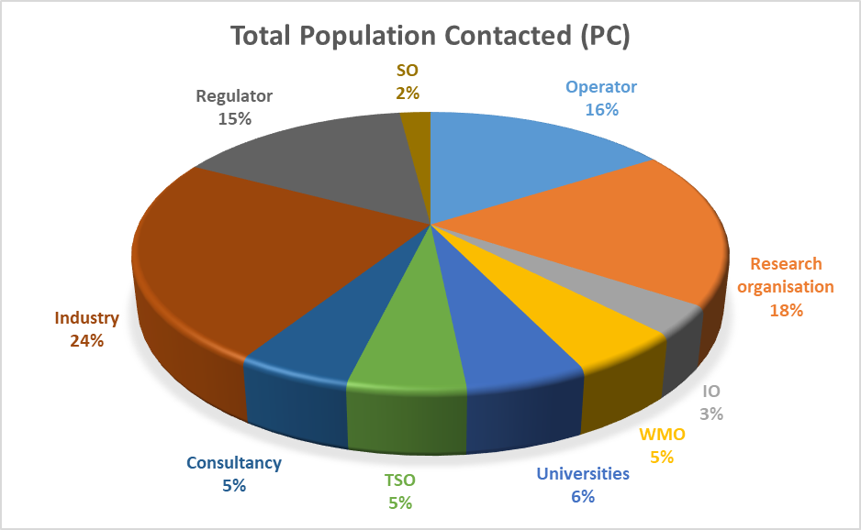 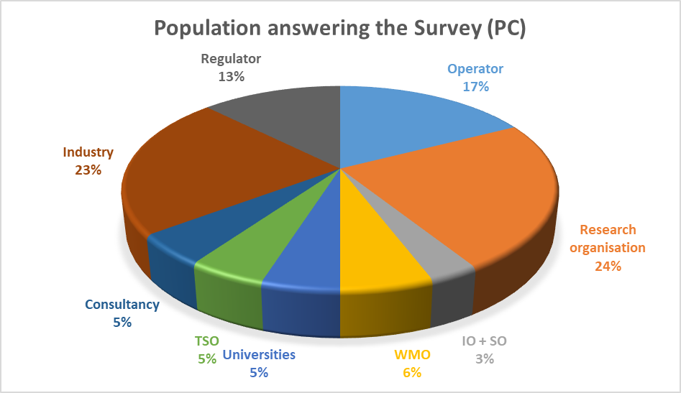

Figure 2‑1. Percentage of different Type of Stakeholders for the Total Population Contacted (left) and the Population answering the Survey (right)

In order to match the Population answering the Survey (PS) with the total Population Contacted (PC), the ratio between the percentage of Population Contacted (PC) and the Population answering the Survey (PS) has been calculated. The final values are summarised in Table 2‑2.

Table 2‑2. Population matching

|  |  |  |  |  |  |
| --- | --- | --- | --- | --- | --- |
| **Type of stakeholder** | **Total Population Contacted (PC)** | | **Population answering the Survey (PS)** | | **ratio (PC/PS)** |
| Nr | % | Nr | % |
| Operator | 103 | 16 | 39 | 17 | **0,92** |
| Research organisation | 118 | 18 | 53 | 24 | **0,77** |
| IO + SO | 35 | 5 | 7 | 3 | **1,74** |
| WMO | 33 | 5 | 13 | 6 | **0,88** |
| Universities | 36 | 6 | 11 | 5 | **1,14** |
| TSO | 35 | 5 | 11 | 5 | **1,11** |
| Consultancy | 34 | 5 | 11 | 5 | **1,07** |
| Industry | 153 | 24 | 51 | 23 | **1,04** |
| Regulator | 98 | 15 | 28 | 13 | **1,22** |
| Total | 645 | 100 | 224 | 100 |  |

Ratios are quite homogeneous among stakeholders’ types showing a ratio close to 1 (Within +/20%) for most of them. They show a good representativeness of the people who answered, at least in link with the population contacted, except in a minor scale for Research organisation and for IO+ SO (little more represented).Those values are used to produce the “Weighted-Population Survey” (see § 2.3.1).

## Weighting Factors identification and assignment

For the identification of the possible weighting factors to be applied for the qualitative analysis of the survey data, a preliminary evaluation of the datasets of demographics has been done.

The demographics can be extracted from the different parameters established in order to define the stakeholder profile:

* Total Population Contacted and Population Answering
* Region
* Country
* Type of Stakeholder
* Status of decommissioning project (Experience)
* Type of Facility
* Number of employees

The selection of the demographics to be used has been performed within WP2 team and it was agreed that the most appropriate to use for obtaining a credible and well-founded weighted analysis are the following:

* Type of Stakeholder
* Status of decommissioning project
* Region

For those kinds of demographics, the different methods used for the weighting factors assignment is reported in the following sub-sections.

In general, for each weighting factor assessment, a committee of decision-makers was formed. It included SHARE WP2 Partners: ENRESA, CEA, IFE, JRC, KIT, LEI and SOGIN who are considered to have an appropriate background for the evaluation and represent different type of stakeholders

Table 2‑3. Committee of decision-makers

|  |  |
| --- | --- |
| **Partner** | **Stakeholder Type** |
| ENRESA | Operator |
| CEA | Research Organisation / Operator |
| IFE | Research Organisation |
| JRC | Research Organisation |
| KIT | Research Organisation / University |
| LEI | Research Organisation |
| SOGIN | Operator / WMO |

### Stakeholders’ Types

Considering the different types of Stakeholders answering the Survey, it is relevant to note that, even if they represent the inventory of relevant actors within the decommissioning and waste management community, they can have different expertise and experience as well as different knowledge about decommissioning operations.

Thus, a weighted analysis based on Stakeholder’s type has been performed: it used a pairwise comparison technique to identify the relative importance weight of the different Stakeholders’ Types considering the importance of their role in the identification of research priorities in the field of decommissioning.

The only one Standardisation Organisation (SO) who answered the survey was considered as Consultancy, thus 9 Stakeholder Types were compared during the analysis:

* 1. Operator
  2. Research organisation
  3. International Organisation
  4. Waste Management Organisation (WMO)
  5. University
  6. Technical Support Organisation (TSO)
  7. Consultancy (including 1 SO)
  8. Industry
  9. Regulator

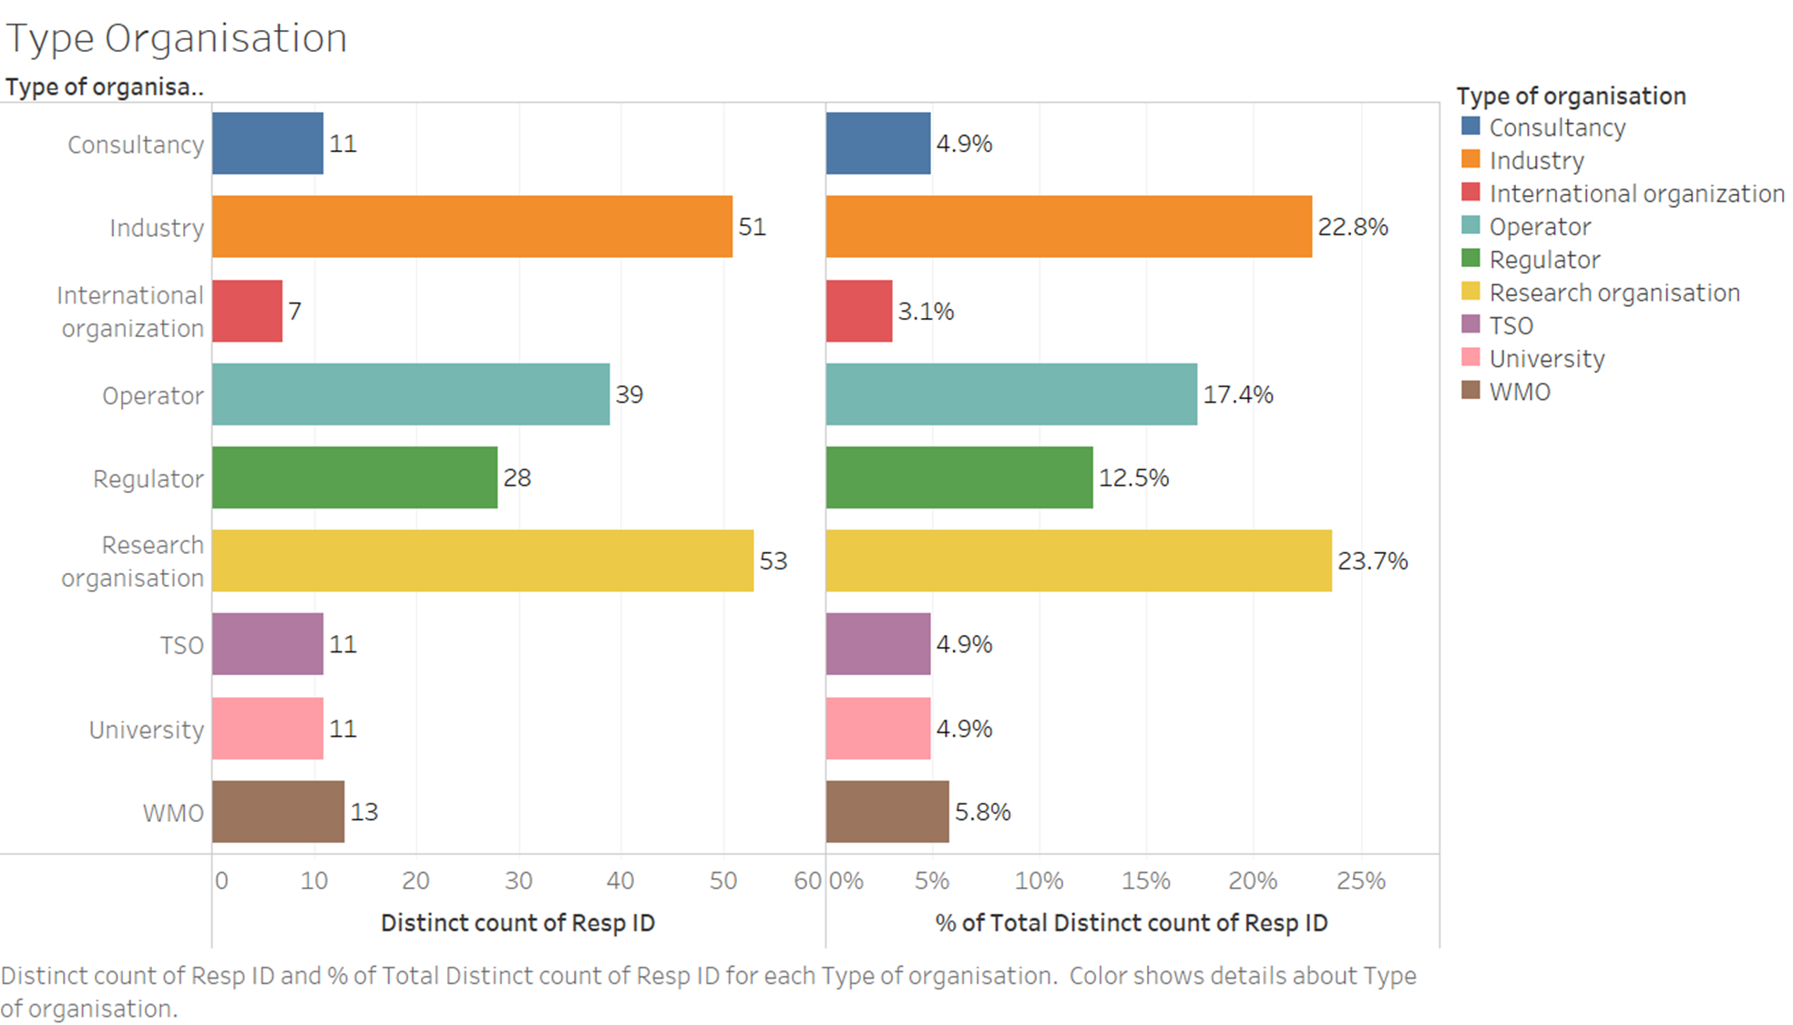

Figure 2‑2. Type of Stakeholders: survey answers

The methodology used involves different steps:

**Step 1: Selecting decision-makers for assessment.**

For the assessment of the pairwise analysis, each member in the committee is required to provide judgments, on the basis of personal knowledge and expertise.

The main goal is to *define the relative importance weight of the different Stakeholders type for the identification of research priorities in the field of decommissioning.*

**Step 2: Making pairwise comparisons and obtaining the individual judgment matrix.**

The evaluators make pairwise comparisons of the importance of (or their preference for) each pair of factors.

A scale of comparison from 1 to 9 is defined (Table 2‑4) and some instruction for the evaluation have been provided (Figure 2‑3)

Table 2‑4. Scale of comparison

|  |  |
| --- | --- |
| **Numeric Rating** | **Degree of preference** |
| **1** | Equal importance |
| 2 | Equally to Moderately |
| **3** | Moderate importance of one factor over another |
| 4 | Moderately to Strong |
| **5** | Strong importance |
| 6 | Strong to very strong |
| **7** | Very Strong importance |
| 8 | Very Strong to extremely |
| **9** | Extreme importance |



Figure 2‑3. Instruction for filling the pairwise comparison matrix

The analysis is performed by using an Excel working file, where a matrix 9x9 is reported (Figure 2‑4). The evaluator put his/her judgment in the upper triangular matrix while the lower part is automatically filled with the reciprocal value of the upper diagonal.



Figure 2‑4. Pairwise comparison matrix

In order to check the transitivity rule for all pair-wise comparisons, a verification matrix for transitivity (Figure 2‑5) is included in the worksheet.



Figure 2‑5. Verification Matrix for Transitivity

The matrix automatically turns the answers:

 if the cell contains a number (aij element of the matrix of pairwise comparisons) consistent with the rule of TRANSITIVITY with respect to the previous numbers. The elements of the matrix adjacent to the top diagonal are not subject to testing as there are no previous relationships they must satisfy.

 if the cell contains a number (element aij of the matrix of pairwise comparisons) NOT consistent with the rule of TRANSITIVITY compared to the previous numbers. It is necessary to review the judgment assigned to the pair of factors corresponding to the warning.

**Step 3: Approximated method for coefficients determination**

This kind of matrix has a single non-zero solution that corresponds to the eigenvector. The positive elements that composed the eigenvector can be normalized to obtain the values that represent the weights of the elements placed in comparison.

A rigorous mathematical method requires the computation of eigenvalues and eigenvectors and can be extremely complicated to solve (for matrices that can have high orders), unless the use of specialized programs, such as Matlab.

In the Figure 2‑6 a representation of the approximated method used in this analysis is reported with some numbers as an example.

It consists in multiplying the elements in each row of the initial matrix (aij*…aij), and then taking the n-th root of that product (where “n” is the rank of the matrix) to have the values of the individual components (green cells under the initials Xi) of the matrix eigenvector. Then this value is normalized through the subsequent division by the total of the sum of the components of the eigenvector just obtained, in order to calculate the normalized eigenvector (light blue cells under the initials Pi).

The weighted coefficients (yellow cells under the “coeff”) are obtained by dividing each the normalized eigenvector (Pi) by the maximum Pi present in the column.

The main eigenvalue is calculated by multiplying each element of the normalized eigenvector (Pi) by the sum of the columns of the non-normalized matrix (Ti) and finally adding the results thus obtained to give max (indicated in the orange cell placed under the cell “max L = sum Yi”.



Figure 2‑6. Approximated method for normalised eigenvector computation

**Step 4: Checking the consistency of individual comparison matrices**

To ensure a decision’s quality, the consistency of the evaluation has to be analysed. Saaty [1] has proposed a consistency index that measures the consistency of comparison matrices. This index can be used to indicate the consistency of the pairwise comparison matrices.

The comparison between the calculated Consistency Index (CI) of the matrix and a value called Random Index (RI), obtained experimentally from the average of the consistency indices of a high sample of matrices, gives back the Consistency Ratio (CR=CI/RI) which allow to measure how consistent the judgments have been relative to large samples of purely random judgments. [2]

The Consistency Index (CI) is calculated from (max‐n)/(n‐1), where n is the rank of the matrix.

The Random Index (RI) is the average of the consistency index values, calculated by a group of specialists, evaluated in relation to a large number of square, reciprocal, positive and random matrices and whose values, depending on the order of the matrix , are shown in the Table 2‑5 below.

Table 2‑5. Average Random Index (RI) based on matrix size

|  |  |
| --- | --- |
| **Size of Matrix** | **Random Consistency Index (RI)** |
| 1 | 0 |
| 2 | 0 |
| 3 | 0,52 |
| 4 | 0,89 |
| 5 | 1,11 |
| 6 | 1,25 |
| 7 | 1,35 |
| 8 | 1,40 |
| 9 | 1,45 |
| 10 | 1,49 |

In case of the example reported in the Figure 2‑6, the Consistency Ratio results equal to 0,34 (see Table 2‑6) thus means that the evaluation done is considered not consistent and must be revised.

Table 2‑6. CR calculation for the example in Figure 2‑6

|  |  |  |
| --- | --- | --- |
| Main eigenvalue | max | 12,96 |
| Matrix size | N | 9,00 |
| Consistency Index: (max-n)/(n-1) | CI | 0,50 |
| Random consistency Index | RI | 1,45 |
| Consistency Ratio: CI/RI | CR | 0,34 |

**Step 5: Assessment of the judgment**

During the first round of the evaluation, each member in the committee is required to provide independently from the other members, his/her own judgment on the basis of personal knowledge and expertise.

A second round is included in the analysis in order to give to the evaluators the possibility to reassess their judgments based on the overall results and comments provided in the first round by the whole committee.

The mean scores of the second round determine the results of the analysis and thus the relative weighting factors.

### Status of Decommissioning project

During the survey the respondents had the possibility to indicate the status of their decommissioning projects among the following:

* None
* Planning
* Ongoing
* Completed/nearly completed

The total data collected are reported in the following Figure 2‑7.

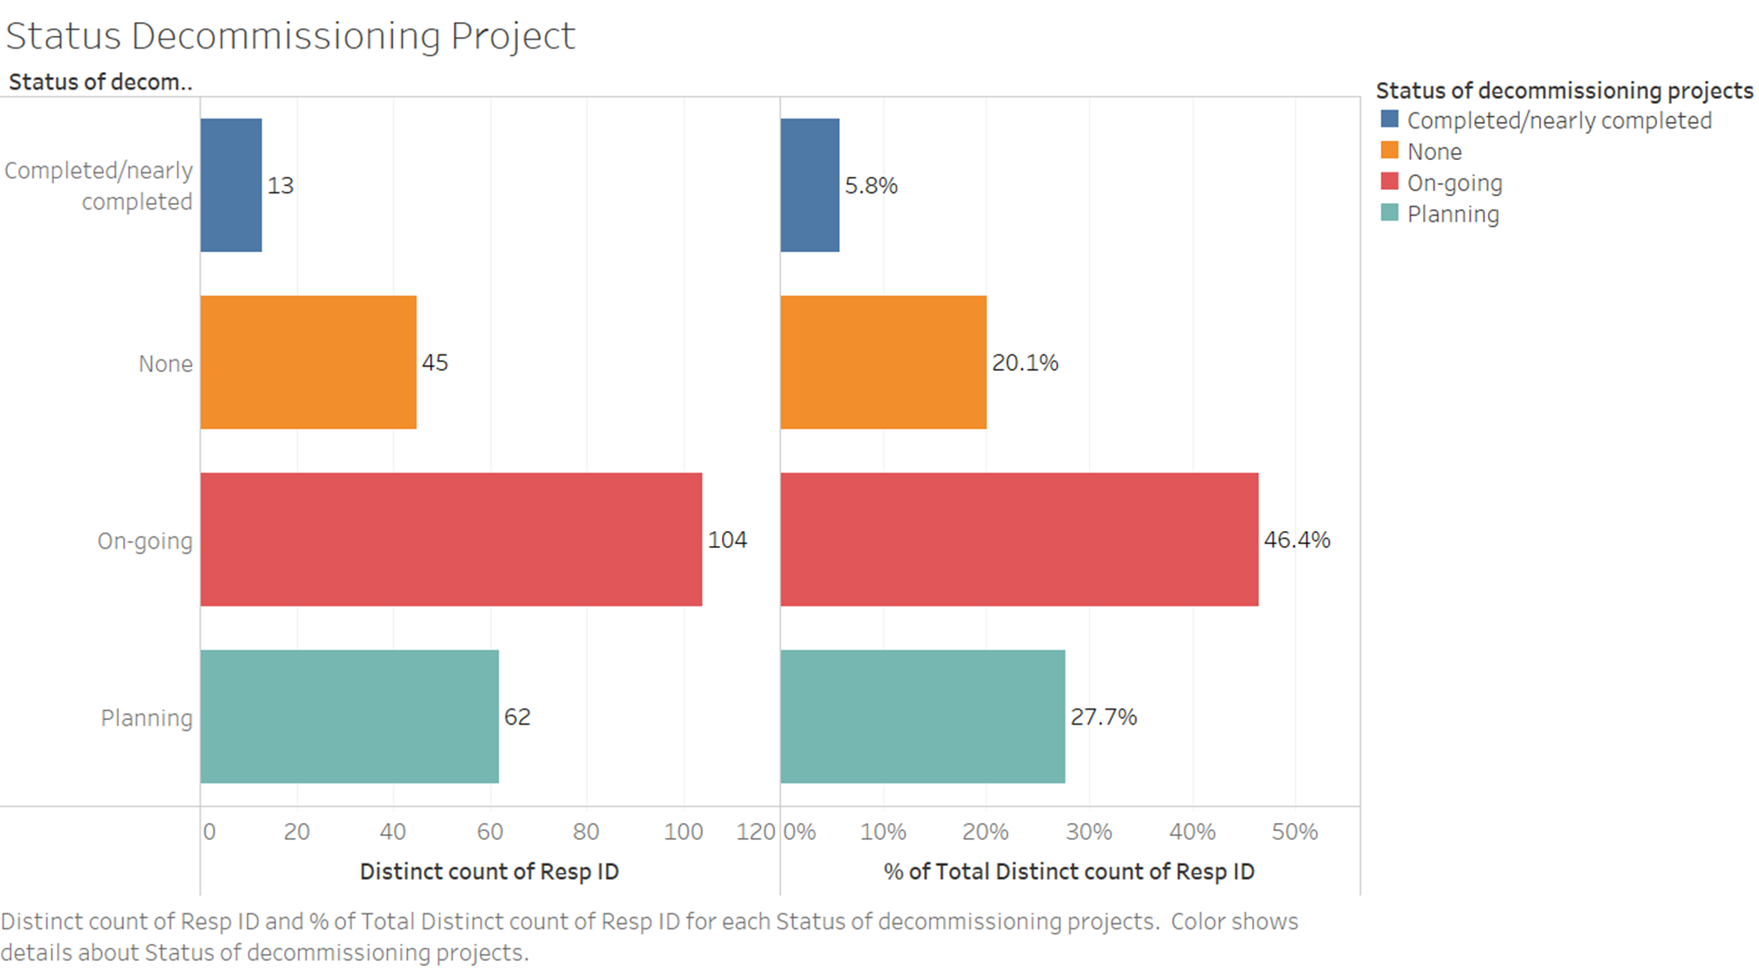

Figure 2‑7. Status of Decommissioning project: survey answers

Even if a full correspondence between the status of the decommissioning project and the relative experience of the organisation who answered could not be stated, it can be possible to evaluate the relevance that different answers (based on different status of decommissioning project) can have as indicator for need of future research in terms of knowledge in decommissioning as a whole.

This is in the scope of the “DELPHI” method selected for this weighting factor assessment.

For the DELPHI method, each member in the committee (on the basis of personal knowledge and expertise) is asked to assign a value, based on a scale from 1 to 5 (see Table 2‑7), to the relative *experience/knowledge* of the different "status of decommissioning project" considering who can have the highest relevance in the questionnaire answering. The evaluator has also the possibility to add comments to the value assigned.

Table 2‑7. Rating scale for DELPHI method

|  |  |
| --- | --- |
| **Rating scale** | |
| **5** | very high experience/knowledge |
| **4** | high experience/knowledge |
| **3** | moderate experience/knowledge |
| **2** | slight experience/knowledge |
| **1** | no experience/knowledge |

The first-round evaluation was collected in a common file together with the eventual comments.

A second round have been carried out for the final assessment of the values.

The relative weighting factors are calculated by dividing each arithmetic mean value (for the 4 categories) by the maximum mean value obtained.



Figure 2‑8. Working file for the DELPHI method evaluation

### Region

Figure 2‑9 shows region coverage by survey. More than half responses were received from EU countries (see Figure 2‑10), resulting in 141 responses. Numerous answers were also received from Asia-Pacific and European countries that are not part of the EU (non-EU) also from America regions, 40, 27 and 13 respectively. Opinion of other regions (Middle East and Africa) were less represented.

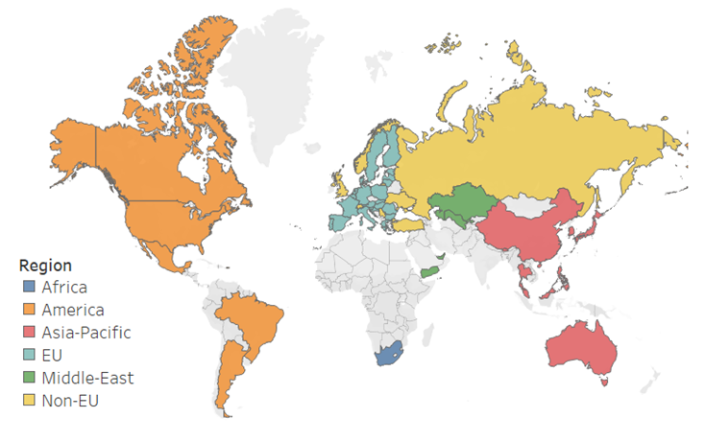

Figure 2‑9. Region coverage

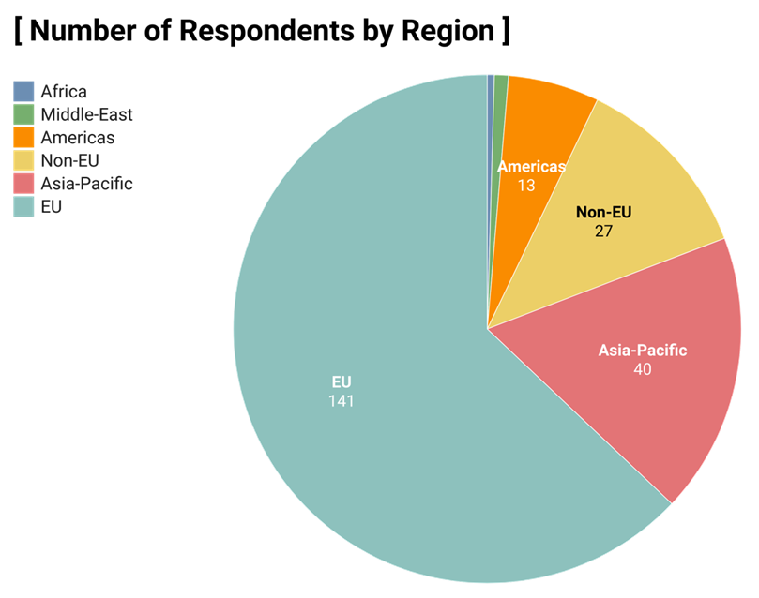

**Africa**

1

**Middle-East**

2

Figure 2‑10. Responses by region

Considering that SHARE is an EC funded project and the roadmap will be mostly implemented in EU and non-EU Countries, a weighting factor of 1 is assigned to EU + Non-EU Regions. Indeed some of the non-EU Countries are associated countries in Horizon 2020.

For the assignment of the weighting factor to the Other Regions (that include Africa, the Americas, Asia-Pacific, Middle East), a qualitative approach based on a General Consensus among the committee has been selected.

For this scope each member in the committee (WP2 Team: ENRESA, CEA, IFE, JRC, KIT, LEI and SOGIN), on the basis of personal knowledge and expertise, has been required to propose a weighting factor (< 1) to be applied to the Other Regions.

The resulted mean value obtained has been discussed among the committee to define at the end the final value to be used.

### Final Weighting Factors

At the end of the second round, the evaluation of the different Partners (see ANNEX II – Completed working file) have been analysed and the mean values obtained for the different analysis performed are summarized in the following Tables.

Table 2‑8. Weighting Factor for Stakeholder Type

|  |  |
| --- | --- |
| **Type of Stakeholder** | **WF Type of Stakeholder  Pair Comparison** |
| Operator | 0,96 |
| Research Organisation | 0,58 |
| International Organization | 0,37 |
| SO (Standardisation Organisation) | 0,16 |
| WMO | 0,60 |
| University | 0,18 |
| TSO | 0,36 |
| Consultancy | 0,16 |
| Industry | 0,58 |
| Regulator | 0,35 |

Table 2‑9. Weighting Factor for Status of decommissioning project

|  |  |
| --- | --- |
| **Status of decommissioning project** | **WF Status decomm DELPHI** |
| Completed/nearly completed | 0,91 |
| none | 0,50 |
| On-going | 1,00 |
| planning | 0,81 |

Table 2‑10. Weighting Factor for Region

|  |  |
| --- | --- |
| **Region** | **WF Region Qualitative** |
| EU | 1,00 |
| non-EU | 1,00 |
| Asia-Pacific | 0,92 |
| America | 0,92 |
| Africa | 0,92 |
| Middle East | 0,92 |

## Weighted Matrix

### Weighted-Population Survey

An example of the weighted matrix used for the Weighted-Population Survey, considering the analysis of the answers of 3 different respondents (R1, R2 and R3, respectively Operator, Research Organisation and TSO) to 3 survey thematic/sub-thematic areas (Q1, Q2 and Q3), is reported in the following Table 2‑11.

Table 2‑11. Example of the Weighted matrix for Weighted-Population Survey

|  |  |  |  |  |  |  |  |  |
| --- | --- | --- | --- | --- | --- | --- | --- | --- |
| **Resp. ID** | **Matching between the survey population and the target population** | **Answer**  ***Importance/Urgency*** | | | **Total**  ***“Weighted-Population Survey”*** | | | |
| PC/PS | Q1 | Q1 | Q3 | | Q1 | Q2 | Q3 | |
| R1 | 0,92 | 3 | 2 | 1 | | 2,76 | 1,84 | 0,92 | |
| R2 | 0,77 | 2 | 5 | 1 | | 1,54 | 3,85 | 0,77 | |
| R3 | 1,11 | 4 | 3 | 4 | | 4,44 | 3,33 | 4,44 | |
| *Total* | | *9* | *10* | *6* | | *8,74* | *9,02* | *6,13* | |

### Weighted-All Survey

After the first matching between the survey population and the target population to obtain the “Weighted-Population Survey”, the final weighted decision matrix is built by multiplying each answer (for importance and urgency) by the sum of the relative weighting factors, to obtain at the end the “Weighted-All Survey”.

An example of the weighted matrix, considering the analysis of the answers of 3 different respondents (R1, R2 and R3) to 3 survey thematic/sub-thematic areas (Q1, Q2 and Q3), is reported in the following Table 2‑12.

Table 2‑12. Example of a weighted matrix for thematic/sub-thematic areas

|  |  |  |  |  |  |  |  |  |  |  |  |
| --- | --- | --- | --- | --- | --- | --- | --- | --- | --- | --- | --- |
| **Resp. ID** | **Weighting Factors** | | | | **Total**  ***“Weighted-Population Survey”*** | | | **Total**  ***“Weighted-All Survey”*** | | | |
| Stake. Type | Status decom. project | Region | WF sum | Q1 | Q2 | Q3 | | Q1 | Q2 | Q3 | |
| R1 | 0,96 | 1,00 | 0,92 | 2,88 | 2,76 | 1,84 | 0,92 | | 7,95 | 5,30 | 2,65 | |
| R2 | 0,58 | 0,50 | 1 | 2,08 | 1,54 | 3,85 | 0,77 | | 3,20 | 8,01 | 1,60 | |
| R3 | 0,36 | 0,81 | 1 | 2,17 | 4,44 | 3,33 | 4,44 | | 9,63 | 7,23 | 9,63 | |
| *Total* | | | | | ***8,74*** | ***9,02*** | ***6,13*** | | ***20,78*** | ***20,54*** | ***13,88*** | |

# Weighted Analysis results – Identification of priorities

As previously described the weighted analysis have been developed into two subsequent steps and two different Survey data have been analysed:

1. Weighted-Population data: which are referred to the matching of the survey population with the target population.
2. Weighted-All data: which are obtained by applying the sum of the defined Weighting Factors to the Weighted-Population data

A first overall comparison of the Weighted-Population and Weighted-All Survey results has been performed. Then a detailed analysis on the general thematic area priorities and sub-thematic area priorities has been set in order to identify common priorities or evident discrepancies when the data are sorted by Region & Country, Type of Organisation, Status of decommissioning project and Type of Facility.

In all the cases the percentage of respondents that selected the Top 2 boxes is used for the visualisation of the data. A Top 2 Box score is a way of summarising the positive responses from the Likert scale survey question. It combines the highest 2 responses of the scale to create a single number. This methodology simplifies the analysis of the data and aids for the identification of priorities and comparison of the results.

In the following sections the main graphs used for the analysis are reported. Additional graphs which can be used for the full visualisation of the data are reported in the ANNEX I – Additional Graphs.

## Global Survey Results

### General thematic areas

The 8 thematic areas addressed are:

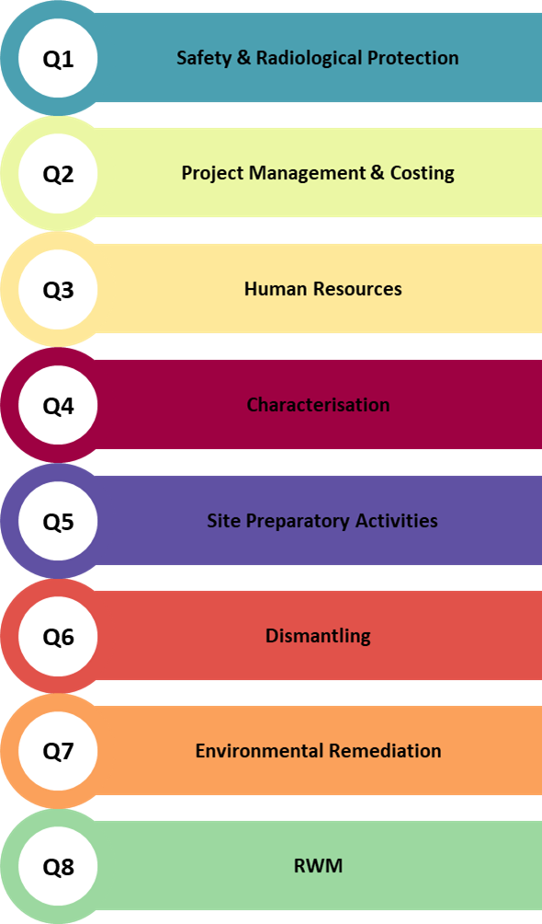

In Figure 3‑1 the percentage of respondents’ positive answers (thematic areas where need for research was ranked top 2 scores) for importance are in the horizontal axis and the percentage of positive answers for urgency is represented by the size of the coloured circles. It is clear from the data that no differences between the Weighted-Population and the Weighted-All results are present neither in case of Importance nor Urgency.

The top four thematic areas remain the same (Characterisation, Radioactive Waste Management, Safety & Radiological Protection and Project Management & Costing).

Dismantling, Environmental Remediation, Human Resources Management and Site Preparatory Activities are confirmed as less priorities for Importance and Urgency.

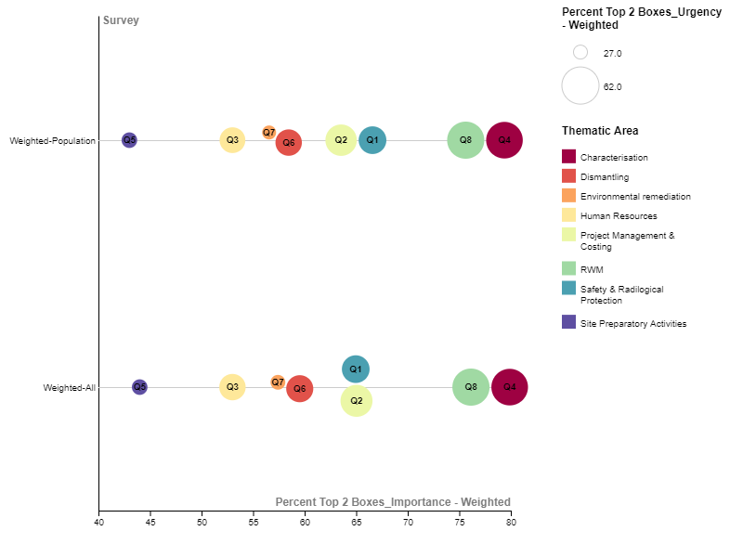

Figure 3‑1. Weighted-Population and Weighted-All _ Importance and Urgency comparison – General thematic areas

### Sub-thematic areas

Each Thematic area is divided in sub-thematic areas as reported below:

|  |
| --- |
|  |
|  |
|  |

The final ranking of the sub-thematic areas in terms of Importance and Urgency of needs for Research both for the Weighted Population and Weighted All data is reported in the tables in ANNEX III – Ranking of sub-thematic areas.

The visualisation of the full data split by sub-thematic areas both for Weighted Population and Weighted All is reported in the Figure 3‑2.

For further analysis of the results obtained with the complete set of sub-thematic areas, two main categories are defined:

* **Non-technical area** category. It includes Safety & Radiological Protection, Project Management & Costing and Human Resources Management
* **Technical area** category. It includes Characterisation, Dismantling, RWM, Site Preparatory Activities and Environmental Remediation

Following Figure 3‑3 shows a comparison of the overall data for importance and urgency obtained for the Weighted-Population and Weighted-All Survey, sorted by technical and non-technical areas is shown. The importance and urgency are represented by the size of the coloured circles

No evident discrepancy between the two weighted analysis of the Survey results is present.

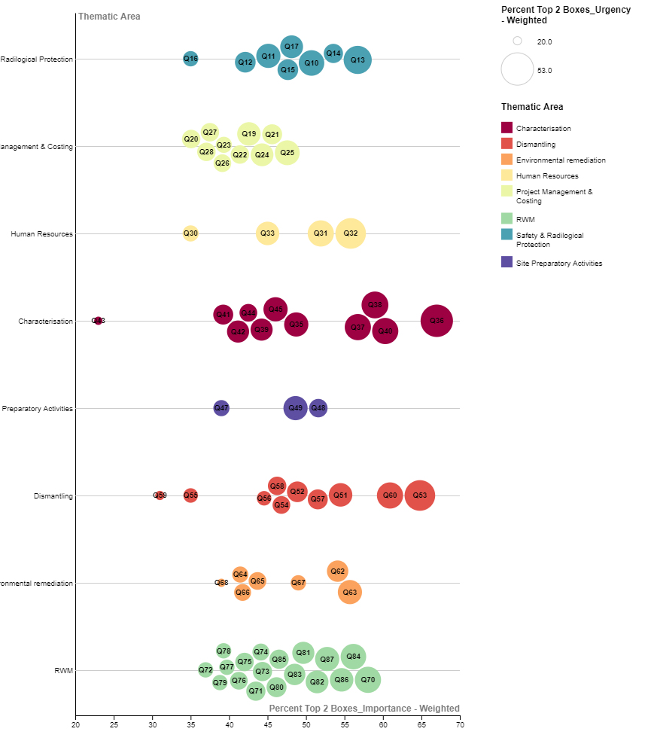 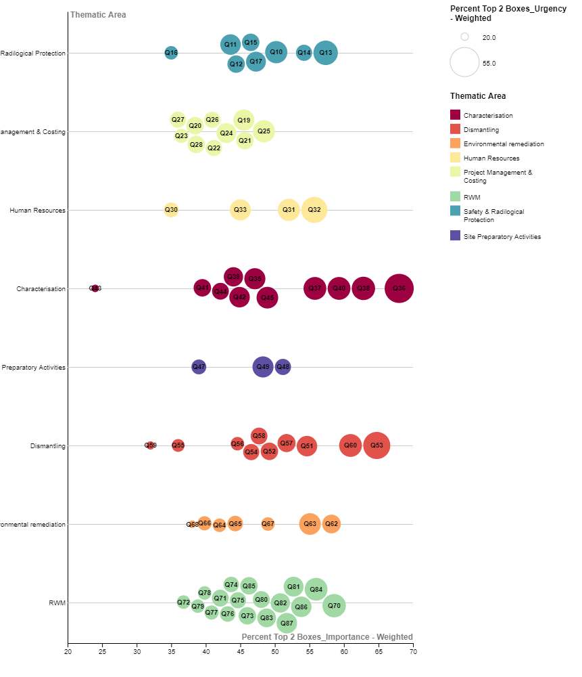

**Weighted-All**

**Weighted-Population**

Figure 3‑2. Global Survey full visualisation - Weighted-Population (left) and Weighted-All (right) – sub-thematic areas

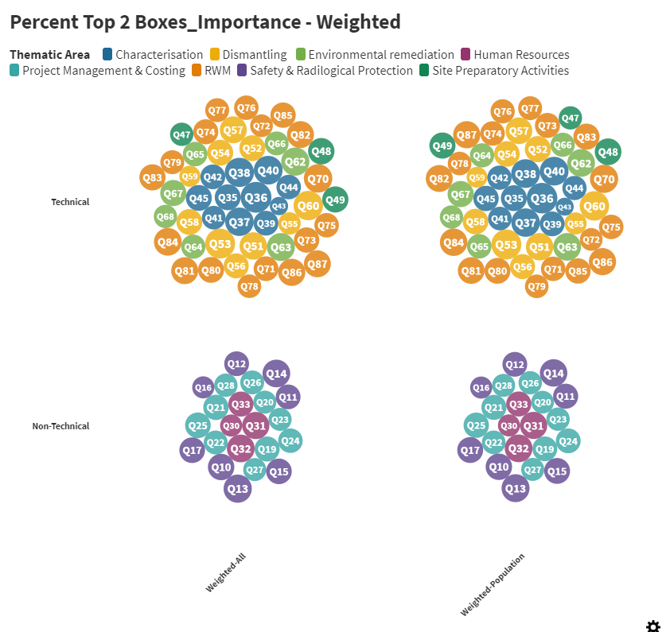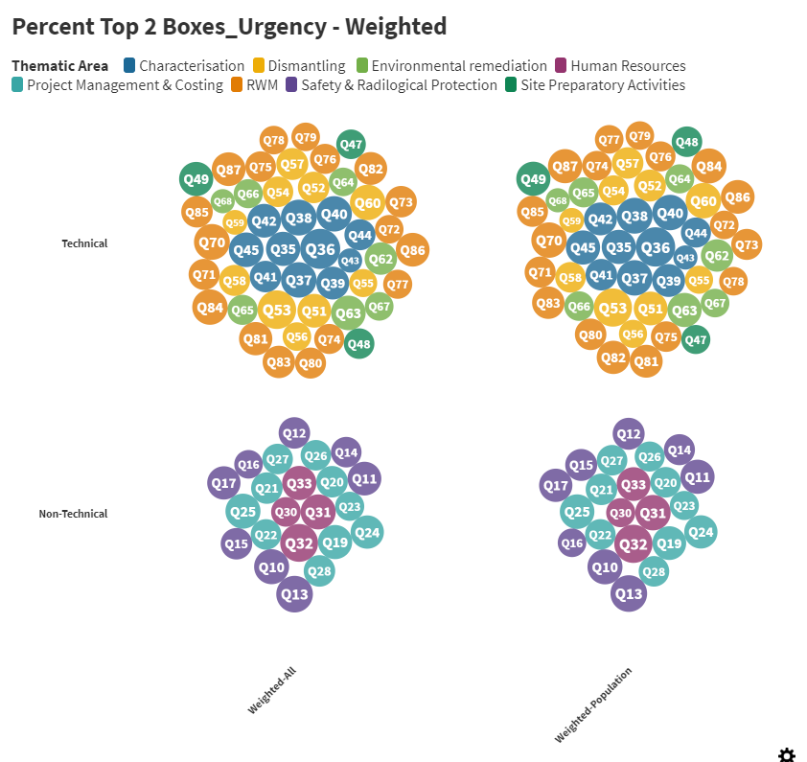

Figure 3‑3. Weighted-Population and Weighted-All Importance and Urgency –Technical and Non-technical sub-thematic areas

A detailed view of the results is obtained with the Top 15 scored sub-thematic areas (see Figure 3‑4).

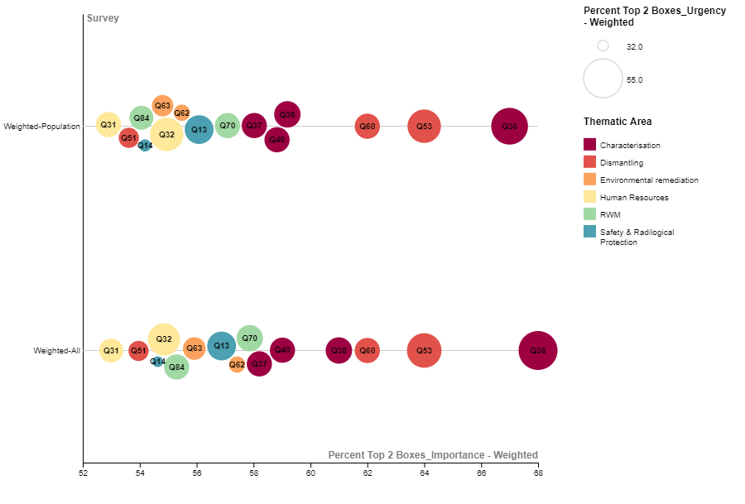

Figure 3‑4. Weighted-Population and Weighted-All importance/Urgency comparison – Top 15 sub-thematic areas

Even if the top 15 sub-thematic areas remain the same with and without the all Weighting Factors, some small differences can be noted in the priorities.

Q36 “Inventory assessment (Radiological and non-radiological)” is confirmed as the Top priority followed by Q53 “In situ Radioactive Waste characterization and segregation”, Q60 “Robots and remote controlled tools for dismantling” and Q38 “Characterisation of activated components and areas (Concrete)”.

The other top priorities include Characterisation (Q37 “Characterisation of activated components and areas (Metal)” and Q40 “Technologies for hard to access areas (high walls, embedded components, harsh environment…)”), RWM (Q70 “Management routes for materials including radioactive waste streams” and Q84 “Material clearance (methodology and procedures)”), Safety & Radiological Protection (Q13 “Development for National regulatory guidance for Decommissioning (Clearance of structures and materials)” and Q14 “Development for National regulatory guidance for Decommissioning (Final site release)”), Environmental Remediation (Q62 “Clearance of surfaces and structures (interiors and exteriors)” and Q63 “Characterisation methods and technologies to identify subsurface contamination”), Dismantling (Q51 “Segmentation of large irradiated metallic components (reactor vessel internals, etc.)”) and Human Resources (Q32 “General education for decommissioning” and Q31 “Methods and software tools for knowledge management (e.g. competence preservation)”).

## Analysis of priorities by Region & Country

Respondents from 49 different countries participated in the survey and their distribution is shown in the Figure 3‑5.

Figure 3‑5. Number of Respondents by Country

Only few countries have enough number of respondents allowing a significant comparative analysis. Concerning the EU region only France, Germany, Spain, Belgium, Italy and Finland were retained for comparison. UK, Japan, South Korea and the US were retained not only because of the significant number of respondents but also to get a regional perspective. The group Other (38 countries) summarised the countries having a few respondents i.e. between 1 and 5 and is not considered for the comparative analysis.

### General Thematic Areas

The results for the thematic area, organized in “Weighted-population” and “Weighted-all” are compared in next graphs. All the results are expressed as the Percent Top 2 Boxes or percentage of respondents' positive answers for importance and urgency.

Figure 3‑6 shows General Thematic Areas sorted by Country. The percentage Top 2N Boxes of respondents' positive answers for Weighted Population and Weighted All, are plotted by Importance on x-axis and by Urgency with size of bubbles.

The graphs show quite well visually which questions for each country have more importance and urgency in weighted survey.

Considering Importance, overall there are small differences between results of Weighted Population and Weighted All, these differences vary between -19% and 21% and for Urgency, the range of differences between results of Weighted Population and Weighted All is between -36% and 30%.

In both graphs, for almost all counties the thematic areas most important and urgent are “Characterisation” and “RWM”, only for Finland these are “Project Management & Costing” and “RWM”; for Japan they are “Project Management & Costing” and “Dismantling”.

For great part of countries, the less important and urgent thematic area is “Site Preparatory Activities”, for Belgium, Finland, Spain and South Korea it is “Human resources”. Generally, the weights assigned to data do not involve great differences in the survey and the results are quite homogeneous.

Overall, in all distributions the data appear quite compact, only for Finland and for Italy there is a marked separation between the more and less important and urgent thematic areas.

|  |  |
| --- | --- |
| **Weighted-Population** | **Weighted-All** |

Figure 3‑6. Countries in Weighted-Population (left) and Weighted-All (right) – General-thematic areas

### Sub-thematic Areas

An overall visualisation of the data (percentage of respondents’ positive answers) filtered by Country, for importance and urgency of need in research for each sub-thematic area is reported in the Figure 3‑7 both for the Weighted-Population and Weighted-All Survey.

The importance and urgency is represented by the size of the coloured circles and it can be noted that there are significant differences among the different Countries both in Importance and Urgency answers. It is clear that France, Japan, UK and USA give an average lower percentage of positive answers (for importance and urgency) for all the sub-thematic areas while countries like Finland, South Korea and Belgium give a higher percentage of positive answers. Spain, Italy and Germany are in the between. No evident discrepancies are noted in case of Weighted-Population and Weighted-All data.

A detailed view of the data is obtained by splitting the sub-thematic areas in the two main categories: Non-Technical and Technical, and by splitting the Countries among the two main Regions: Europe (EU) and Other. The relative graphs are reported in the ANNEX I – Additional Graphs.

In case of EU-Region some small differences among the priorities are noted comparing Weighted Population and Weighted All data but globally, the results are consistent, showing some clear priorities highlighted for specific Countries:

* For Technical Areas: clear priorities are Q36 “Inventory assessment (Radiological and non-radiological)” and Q40 “Technologies for hard to access areas (high walls, embedded components, harsh environment…)” for Italy
* For non-technical Areas: clear priorities are Q32 “General education for decommissioning” for Finland, Q13 “Development for National regulatory guidance for Decommissioning (Clearance of structures and materials)” and Q14 “Development for National regulatory guidance for Decommissioning (Final site release)” for Belgium and Q10 “International harmonization of safety standards and safety approaches for Decommissioning” and Q19 “Methodologies and software tools for comparison of alternative decommissioning strategies” for France.

In case of Other Regions smaller differences among the priorities are present between Weighted Population and Weighted All data but globally, the results are consistent, showing that the trends are confirmed both for technical and non-technical areas:

* For Technical Areas: UK highlighted a clear priority for Q81 “Radioactive waste conditioning” and Q35 “Methodology for historical site assessment”, US for Q53 “In situ Radioactive Waste characterization and segregation”.
* For non-Technical Areas: Q14 “Development for National regulatory guidance for Decommissioning (Final site release)” is a clear priority for Japan, South Korea and USA (where also Q17 “Development of radiological protection approaches and guidance for Decommissioning” is a priority). For UK the highlighted priority is Q32 “General education for decommissioning”.

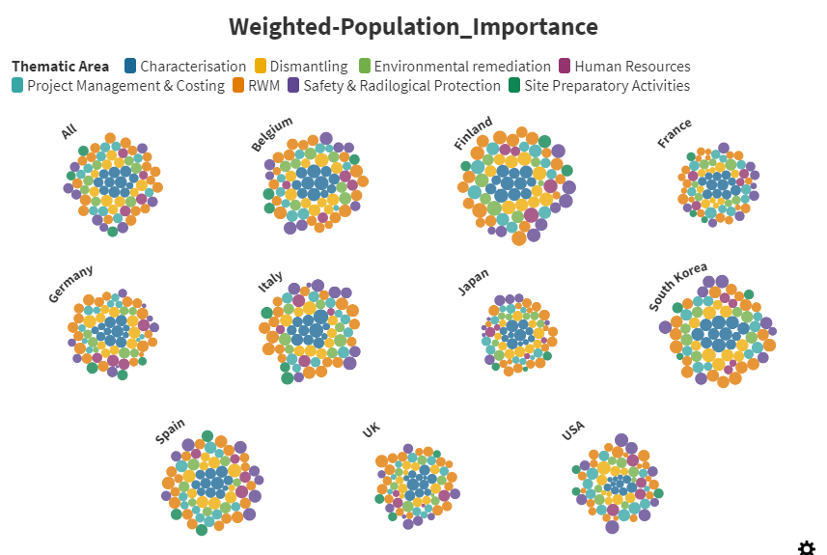 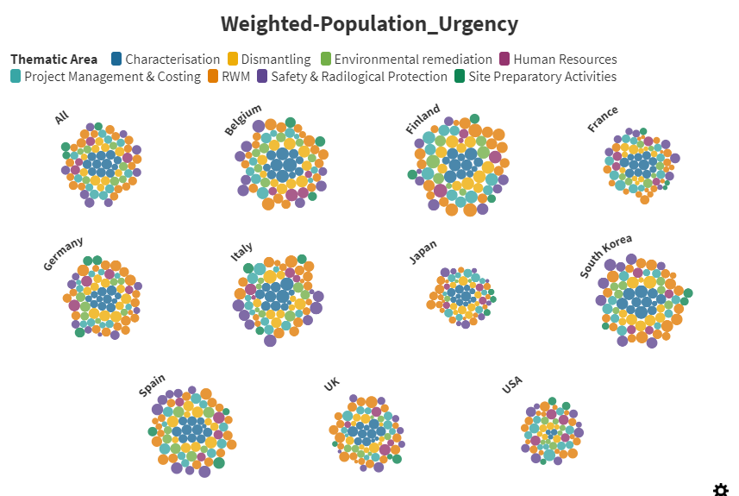

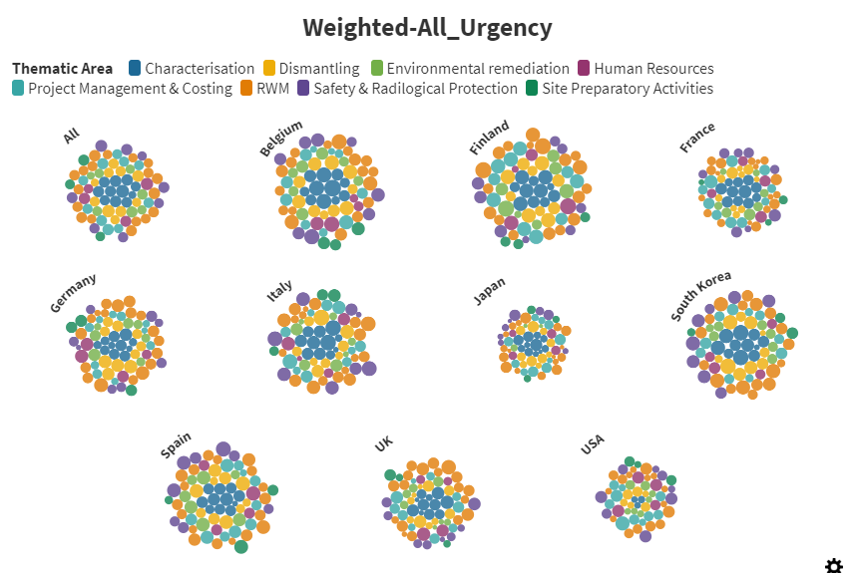

Figure 3‑7. Sub-Thematic Weighted-Population (top) and Weighted All (bottom) data for Importance (left) and Urgency (right) _ sorted by Country

A focus on the Top 15 priorities for Importance for all the different Countries is reported in the following Figure 3‑8 for both the Weighted-Population and Weighted-All data.

The percentage of positive answers for importance are in the horizontal axis and the percentage of positive answers for urgency is represented by the size of the coloured circles. The data are vertically sorted to show the descending trends of the values.

It can be noted that: when one or more than one evident priority is identified by a Country, it is confirmed in the Weighted-All Survey, while when the priorities are very close for importance, some changes are evidenced.

The common Importance priorities among the different Countries are reported in the Figure 3‑9 where, among the top 15 importance priorities for each Country, the ones with more than 3 common “interested” Countries are showed. Globally, the results are consistent showing that the most common priorities in terms of Importance are:

* + Characterisation: Q36 “Inventory assessment (Radiological and non-radiological)” and Q40 “Technologies for hard to access areas (high walls, embedded components, harsh environment…)”
  + Dismantling: Q53 “In situ Radioactive Waste characterization and segregation” and Q60 “Robots and remote controlled tools for dismantling”
  + Environmental remediation: Q63 “Characterisation methods and technologies to identify subsurface contamination”
  + Human Resources: Q32 “General education for decommissioning”
  + RWM: Q70 “Management routes for materials including radioactive waste streams” and Q84 “Material clearance (methodology and procedures)”
  + Project Management & Costing: Q19 “Methodologies and software tools for comparison of alternative decommissioning strategies” is the only sub-thematic area with at least 3 common “interested” countries
  + Safety & Radiological Protection: Q13 “Development for National regulatory guidance for Decommissioning (Clearance of structures and materials)” and Q14 “Development for National regulatory guidance for Decommissioning (Final site release)”
  + Site Preparatory Activities: no significant common priorities

This Figure also shows that even for the most common priorities, there is big difference of opinion among countries: no sub-thematic area showed consensus of the 10 countries considered in this analysis, only one with 9 countries (Q53 on “In situ Radioactive Waste characterization and segregation” ), the average being around 3 to 4 countries only

|  |  |
| --- | --- |
| **Weighted-Population**  **Weighted-All** |  |

Figure 3‑8. Weighted-Population (left) and Weighted-All (right) _ Top 15 _ Country

|  |  |
| --- | --- |
| **Weighted-All**  **Weighted-Population** |  |

Figure 3‑9. Weighted-Population (left) and Weighted-All (right) _ common Importance Priorities among the top 15 top priorities _ Country

## Analysis of priorities by Type of Organisation

Respondents from 9 different types of Organisation participated in the survey and their distribution is shown in the Figure 3 8.

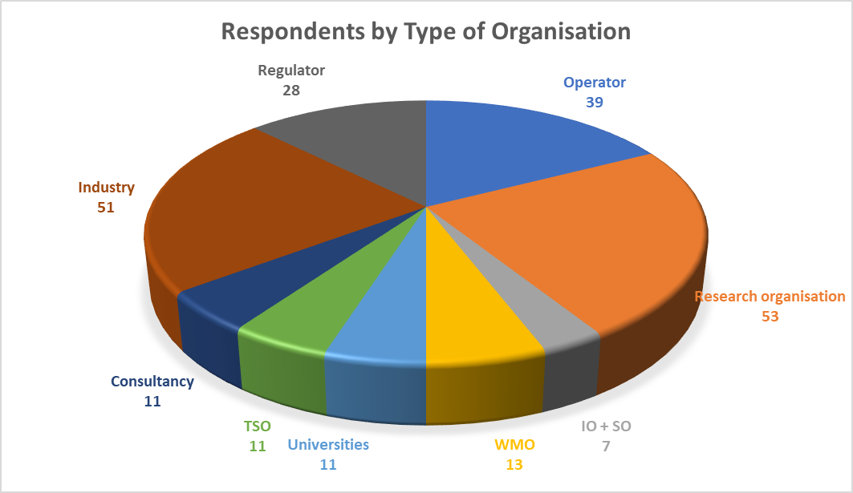

Figure 3‑10. Number of Respondents by Type of Organisation

Regarding Type of organisation, the responses are analysed by thematic area and sub-thematic area, also in this case it was made a difference in technical and non-technical areas to have a better visualization of data. The graphs show a comparison between “Weighted population” and “Weighted All” data with the percentage of positive responses (top 2 scores of the survey = 4 and 5 on Likert scale).

### General Thematic Areas

General thematic areas are analysed in the next graphs. The first one (Figure 3‑11) gives a global representation of all the percentage of respondents’ positive answers for “Weighted Population” and “Weighted All” filtered by Type of Organisation combining “importance” and “urgency”. The importance and urgency are represented respectively by the values on the x axis and the size of the coloured circles.

As we can see, the shape of distribution is rather similar for “Weighted Population” and “Weighted All” data, with the same minimum and maximum values.

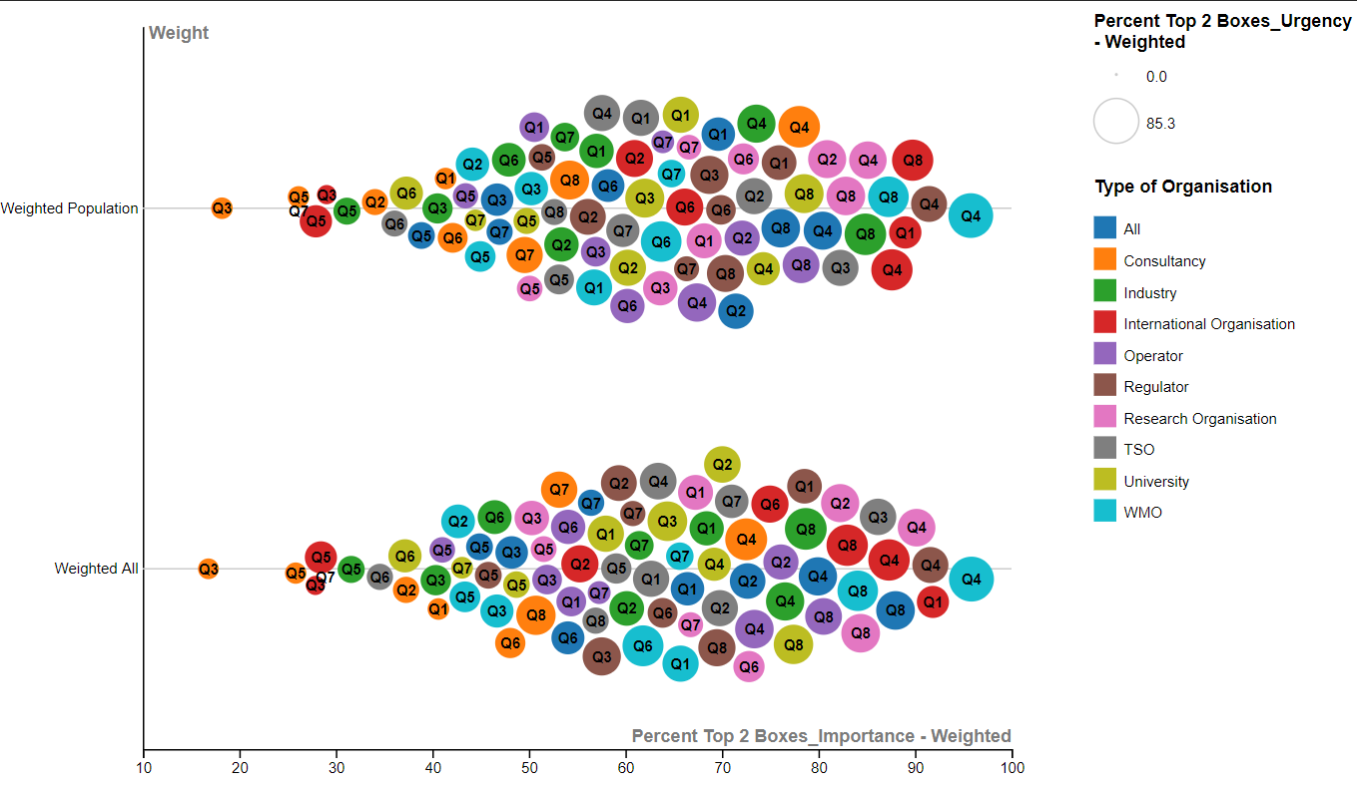

Figure 3‑11. Weighted Population - Weighted All comparison for general thematic areas. Type of Organisation.

The next figure (Figure 3‑12) shows a comparison between “Weighted-Population” (left) and “Weighted-All” (right) data for Type of Organisation.

In general, it can be noted that there are minimal differences between the results of Weighted Population and Weighted All data. Only for WMO there are small variations between “Weighted-Population” and “Weighted-All” data. But globally, the results are showing that the most important and urgent thematic area is “Characterization” for the most types of Organisation. It is little less important than “RWM” for Industry and Operator and not so important for TSO where the most important and urgent one is “Human Resources”.

In all analysis, “Site Preparatory Activities” is the general thematic area presenting less important and urgent need for Research for Industry, International Organisation, Operator, Regulator and Research Organisation; it is “Dismantling” for TSO and University; it is “Human Resources” for Consultancy. Only for WMO, needs in “Project Management &Costing” are little less important than in “Site Preparatory Activities” in “Weighted Population” as compared to “Weighted All” data.

|  |  |
| --- | --- |
| **Weighted-Population**  **Weighted-All** |  |

Figure 3‑12. Type of Organisation in Weighted-Population (left) and Weighted-All (right) – General-thematic areas

### Sub-thematic Areas

An overall visualisation of the data (percentage of respondents’ positive answers) filtered by Country, for importance and urgency of need in research for each sub-thematic area is reported in the Figure 3‑13 both for the Weighted-Population and Weighted-All Survey.

The importance and urgency are represented by the size of the coloured circles and it can be noted that there are no significant evident differences among the shape of distribution for the different Type of Organisation both in Importance and Urgency answers. Only for International Organisation a different shape distribution is observed.

By splitting the sub-thematic areas in the two main categories: Non-Technical and Technical (the relative graphs are reported in the ANNEX I – Additional Graphs) it can be noted that:

* In case of technical areas most Types of Organisation didn’t highlight specific priorities apart from International Organisation who identified as clear priority: Q51 “Segmentation of large irradiated metallic components (reactor vessel internals, etc.)”, Q49 “Systems decontamination (internal)” and Q87 “Conventional and cleared materials recycling (circular economy)”; Consultancy and WMO who identified Q36 “Inventory assessment (Radiological and non-radiological)” as a clear priority and TSO who identified Q87 “Conventional and cleared materials recycling (circular economy)” as the top priority.
* In case of Non-technical areas a clear priority is identified by TSO in Q31 “Methods and software tools for knowledge management (e.g. competence preservation)”, by Consultancy in Q32 “General education for decommissioning” and by International Organisation in Q10 “International harmonization of safety standards and safety approaches for Decommissioning”.

|  |  |
| --- | --- |
|  |  |

Figure 3‑13. Sub-Thematic Weighted-Population (top) and Weighted All (bottom) data for Importance (left) and Urgency (right) _ sorted by Type of Organisation

A focus on the Top 15 priorities for Importance of needs for Research for all the different Type of Organisation is reported in the following Figure 3‑14 for both the Weighted-Population and Weighted-All data.

The data are vertically sorted to show the descending trends of the values and in the Weighted-All Survey TSO is confirmed as the one who gives the highest values (percentage of positive answers) to his top 15 priority needs and University replaces International Organisation at the second place.

No evident discrepancies are present in the results of the Weighted-Population and Weighted-All Survey and it can be noted that: when one or more than one evident priority is identified by a specific Type of Organisation, it is confirmed in the Weighted-All Survey, while when the priorities are very close for importance, some changes are evidenced.

The common Importance priorities among the different Types of Organisation are reported in the Figure 3‑15, where, among the top 15 importance priorities for each Type of Organisation, the ones with more than 3 common “interested” Organisations are showed.

It can be noted that some common priorities (basically related to RWM and Safety & Radiological Protection) changes between Weighted-Population and Weighted-All Survey data.

RWM Q84 and Q86 have more than 3 common interested organisations in the Weighted All and not in the Weighted Population, Safety & Radiological Protection Q11, Q15 and Q17 have 3 common interested organisations in the Weighted Population and not in the Weighted All.

But globally, the results are consistent that the most common priorities in terms of Importance are:

* + Characterisation: Q36 “Inventory assessment (Radiological and non-radiological)”, Q37 “Characterisation of activated components and areas (Metal)”, Q38 “Characterisation of activated components and areas (Concrete)” and Q40 “Technologies for hard to access areas (high walls, embedded components, harsh environment…)”
  + Dismantling: Q51 “Segmentation of large irradiated metallic components (reactor vessel internals, etc.)”, Q53 “In situ Radioactive Waste characterization and segregation” and Q60 “Robots and remote controlled tools for dismantling”
  + Environmental remediation: Q62 “Clearance of surfaces and structures (interiors and exteriors)” and Q63 “Characterisation methods and technologies to identify subsurface contamination”
  + Human Resources: Q32 “General education for decommissioning”
  + RWM: Q70 “Management routes for materials including radioactive waste streams”, Q84 “Material clearance (methodology and procedures)” and Q87 “Conventional and cleared materials recycling (circular economy)”
  + Safety & Radiological Protection: Q13 “Development for National regulatory guidance for Decommissioning (Clearance of structures and materials)” and Q14 “Development for National regulatory guidance for Decommissioning (Final site release)”
  + Site Preparatory Activities: Q48 “Preparation of infrastructures and buildings for decommissioning (storages, capabilities for material sorting and treatment...)”
  + Project Management & Costing: no significant common priorities

This Figure also shows that even for the most common priorities, there is big difference of opinion among types of organisation: no sub-thematic area showed consensus of the 9 types of organisation considered in this analysis, only 1 with 8 types (Q36 “Inventory assessment (Radiological and non-radiological”) and 1 with 7 types (Q38 “Characterisation of activated components and areas (Concrete)”), the average being around 4 organisation types only.

|  |  |
| --- | --- |
| **Weighted-Population** |  |

**Weighted-All**

Figure 3‑14. Weighted-Population (left) and Weighted-All (right) _ Top 15 _ Type of Organisation

|  |  |
| --- | --- |
| **Weighted-All**  **Weighted-Population** |  |

Figure 3‑15. Weighted-Population (left) and Weighted-All (right) _ common Importance Priorities among the top 15 top priorities _ Type of Organisation

## Analysis of priorities by Status of Decommissioning Project

In the following sub-sections, the analysis of the weighted responses of survey is filtered by status of decommissioning projects. The general thematic areas and the sub-thematic areas are, in each case “Weighted Population” and “Weighted All” data are compared. The percentage of Top 2 boxes is used for the visualisation of all the data

Respondents were asked to indicate the Status of Decommissioning Project and the percentage of relative answers is reported in the following Figure 3‑16.

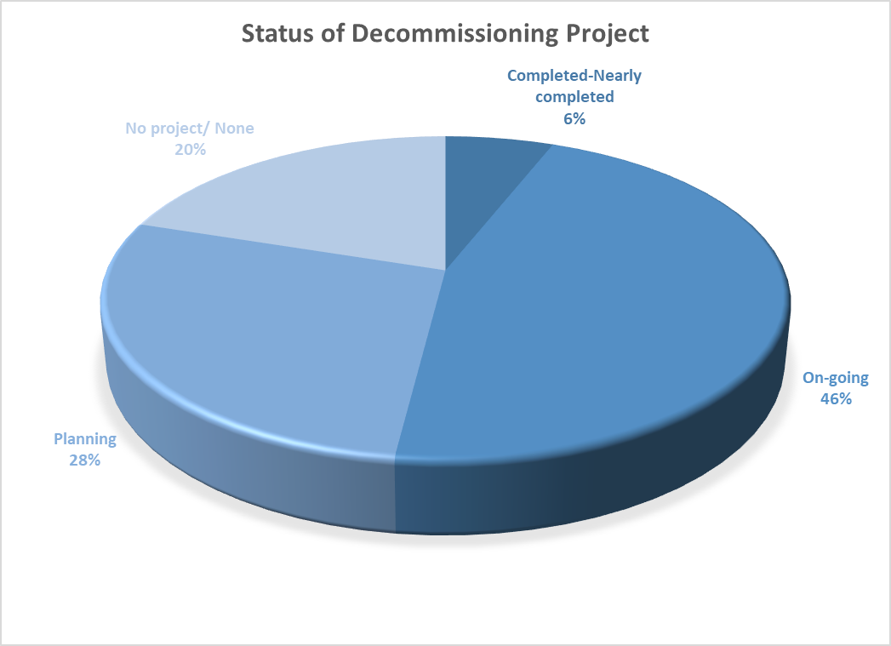

Figure 3‑16. Percentage of Respondents per Status of decommissioning project

### General Thematic Areas

About the Status of decommissioning project, the next figure shows the distribution of general thematic areas for “Weighted Population” and “Weighted All” plotted by importance and urgency. Generally, the shape of both distributions is very similar

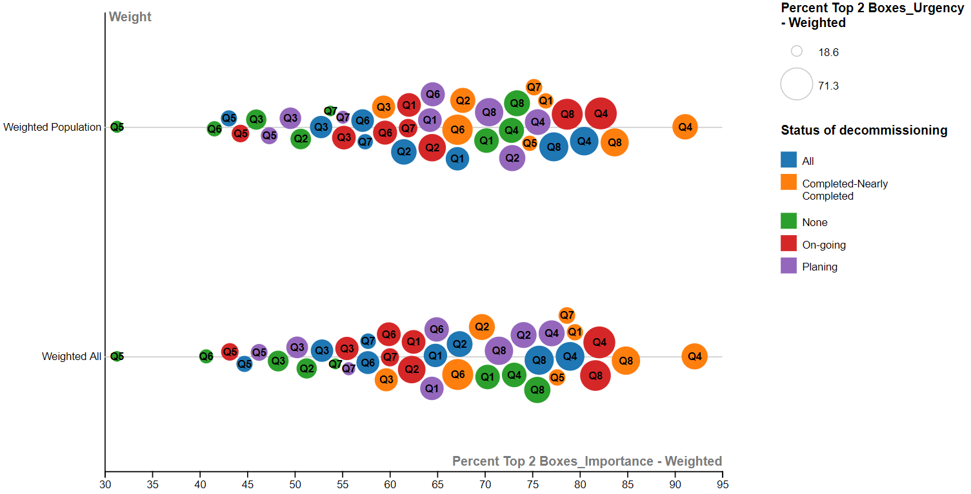

Figure 3‑17. Weighted Population - Weighted All comparison for general thematic areas. Status of decommissioning.

Next graph (Figure 3‑18) gives a more detailed representation for “Weighted-Population” and “Weighted-All” data by status of decommissioning projects. There are small differences between the two type of weighted data. For both graphs Q4 (Characterization), Q8 (Management of waste and material) are the highest scored thematic areas for importance and urgency. For On-going and Planning Status, Q2 (Project management and costing) have a relevant percentage.

There is consensus on the least important and urgent need for Research in the thematic areas Q5 (Site preparatory activities).

|  |  |
| --- | --- |
| **Weighted-Population** | **Weighted-All** |

Figure 3‑18. Status of decommissioning in Weighted-Population (left) and Weighted-All (right) – General-thematic areas

### Sub-thematic Areas

By splitting the sub-thematic areas in the two main categories: Non-Technical and Technical (the relative graphs are reported in the ANNEX I – Additional Graphs) it can be noted that:

* For Technical Areas there are small differences between “Weighted-Population” and “Weighted-All” data. Items connected to “Characterisation” (Q36 “Radiological and non-radiological inventory assessment”) and “Dismantling” “Q53 “In situ Radioactive Waste characterization and segregation”) are the most important and urgent for almost all Status of decommissioning project. For Completed-nearly completed status Q62 “Clearance of interiors and exteriors surfaces and structures” and Q63 “Characterisation methods and technologies to identify subsurface contamination” connected to “Environmental remediation” have higher priority. Q43 “Geostatistical software application” is the less important and urgent sub thematic area for all decommissioning status, Q59 “Demolition of large, reinforced concrete structures” is not relevant too.
* For non-Technical Areas: “Weighted Population” and “Weighted All” distributions are very similar. For Planning, On-going and Completed-nearly completed status of decommissioning Q13 “Development for National regulatory guidance for Decommissioning (Clearance of structures and materials)” is the most important and urgent sub-thematic area related to “Safety and Radiological Protection”; for None respondents Q32 “General education for decommissioning” is the most important and urgent item connected to “Human Resources”. All the status of decommissioning project highlight less needs connected to the sub-thematic areas Q16 “Methods and tools for conventional industrial safety” and Q30 “Organisation models for staff and resources”, respectively related to “Safety and Radiological Protection” and “Human resources” thematic areas. All the “project management and costing” sub-thematic areas are positioned in the middle of both Weighted Population and Weighted All survey, tending towards lower values for all Status of decommissioning project.

A focus on the Top 15 priorities for Importance for all the different Status of Decommissioning project is reported in the following Figure 3‑14 for both the Weighted-Population and Weighted-All data.

The data are vertically sorted to show the descending trends of the values. The general trend is maintained in the Weighted-Population and Weighted-All Survey.

Completed-Nearly completed decommissioning status gives highest priority to environmental remediation (Q62 “Clearance of surfaces and structures (interiors and exteriors)” and Q63 “Characterisation methods and technologies to identify subsurface contamination”), RWM (Q73 “Radioactive material treatment processes (metals)” and Q74 “Radioactive material treatment processes (concrete)”) and Safety and radiological protection (Q10 “International harmonization of safety standards and safety approaches for Decommissioning”) sub-thematic areas, while planning and on-going decommissioning status considered Dismantling (Q53 “In situ Radioactive Waste characterization and segregation”) and Characterisation (Q36 “Inventory assessment (Radiological and non-radiological”) as the most important sub-thematic areas. Respondents who indicated “None” as status of decommissioning project gave in general the lowest values (percentage of positive answers) to his top 15 priority needs and identified Human Resources (Q32 “General education for decommissioning”) as the top priority.

Comparing the results of the Weighted-Population and Weighted-All Survey, the only evident change is in the on-going status (where Q48 present in the top 15 of the Weighted-Population is replaced by Q82 in the Weighted-All) and in the None status (where Q51 is replaced by Q14). No sub-thematic area related to Site Preparatory activity is present in the top 15 priorities in the Weighted-All Survey.

The common Importance priorities among the different Status of Decommissioning project can be seen in the Figure 3‑20, where the top 15 importance priorities for each Status of Decommissioning project are plotted.

It can be noted that the main common priorities in terms of importance (basically related to Dismantling, RWM and Safety & Radiological Protection) are the same in the Weighted-Population and Weighted-All and they are:

* + Characterisation: Q36 “Inventory assessment (Radiological and non-radiological)” is a common priority for all the status and Q40 “Technologies for hard to access areas (high walls, embedded components, harsh environment…)” is a common priority for none, planning and on-going status
  + Dismantling: Q60 “Robots and remote controlled tools for dismantling” is a common priority for all the status and Q53 “In situ Radioactive Waste characterization and segregation” is a common priority for none, planning and on-going status
  + Environmental remediation: Q62 “Clearance of surfaces and structures (interiors and exteriors)” and Q63 “Characterisation methods and technologies to identify subsurface contamination” are common priorities for completed-nearly completed, on-going and planning status
  + Human Resources: no significant common priorities. Only none status indicated sub-thematic area related to Human Resources as a top 15 priority
  + Project Management & Costing: no significant common priorities. Only none status indicated sub-thematic area related to Project Management & Costing as a top 15 priority
  + RWM: Q70 “Management routes for materials including radioactive waste streams” is a common priority for none, planning and on-going status
  + Safety & Radiological Protection: Q13 “Development for National regulatory guidance for Decommissioning (Clearance of structures and materials)” is a common priority for all the status and Q14 “Development for National regulatory guidance for Decommissioning (Final site release)” is a common priority for completed-nearly completed, on-going and none status
  + Site Preparatory Activities: no common priorities

This Figure also shows that even for the most common priorities, there is big difference of opinion among stakeholders depending on the status of Decommissioning projects: only 3 sub-thematic areas showed consensus of the 4 types of stakeholders considered in this analysis, the average being around 2 types only.

|  |  |
| --- | --- |
| **Weighted-Population** |  |

**Weighted-All**

Figure 3‑19. Weighted-Population (left) and Weighted-All (right) _ Top 15 _ Status of Decommissioning project

|  |  |
| --- | --- |
| **Weighted-All**  **Weighted-Population** |  |

Figure 3‑20. Weighted-Population (left) and Weighted-All (right) _ common Importance Priorities among the top 15 top priorities _ Status of Decommissioning project

## Analysis of priorities by Type of Facility

This sub-section concerns the analysis of priorities by Type of facility, the next graphs show weighted data as percentage of Top 2 boxes for the visualisation of general thematic areas and sub-thematic areas, they are filtered by Type of facility. The visualisation of the data is distinct in “Weighted Population” and “Weighted All”, in all graphs the importance is plotted on x axis and the urgency is expressed by the size of bubbles. In this way the priorities are visualized with a direct impact.

Considering the total answers received the percentage of each different “Type of Facility” indicated by the respondents is summarised in the following Figure 3‑21.

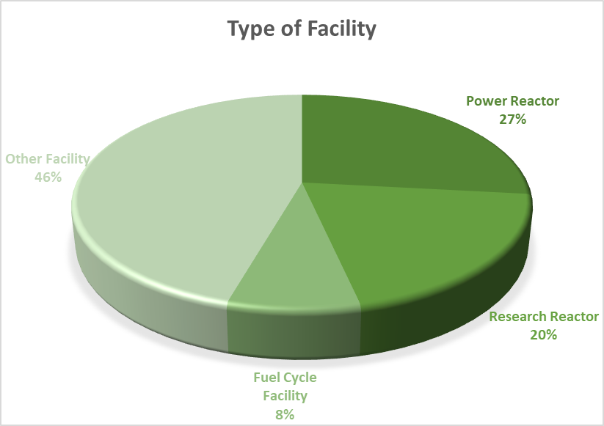

Figure 3‑21. Percentage of Respondents per Type of Facility

### General Thematic Areas

The next figure shows that “Weighted Population” and “Weighted all” data have the same distribution; the general thematic areas are reported with the same trend on the chart.

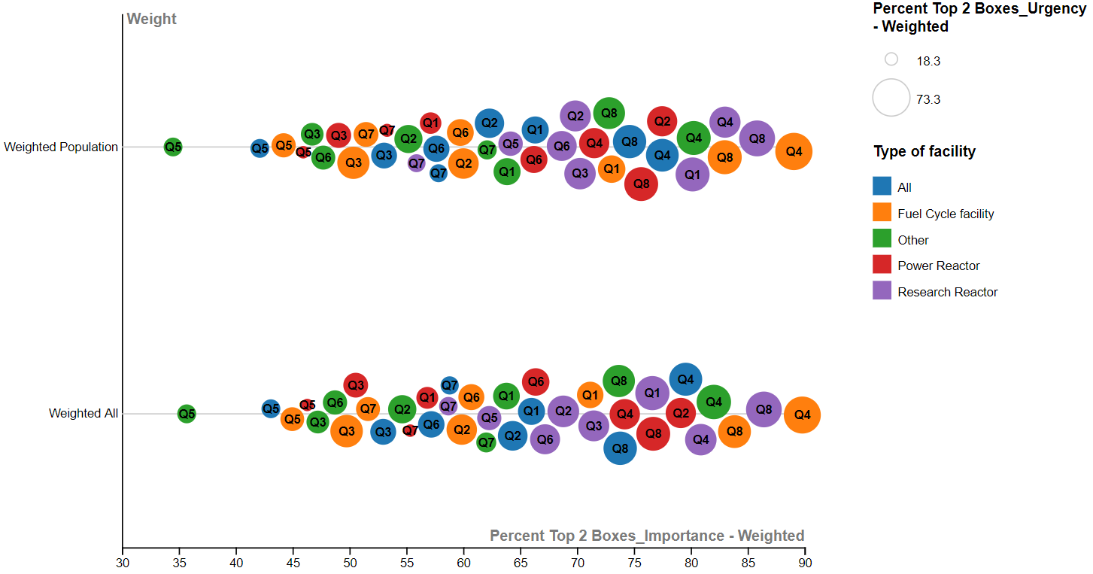

Figure 3‑22. Weighted Population - Weighted All comparison for general thematic areas. Type of facility.

As it could be seen in Figure 3‑23, for all Type of facility, the general thematic areas show very similar priorities for “Weighted Population” and “Weighted All”. Both the graphs have a similar rank of percent Top 2 Boxes of weighted responses, in fact there is no significant position exchanges of general thematic areas: for all “Type of facility” general thematic areas with most important and urgent needs for Research are Q4 (Characterization during decommissioning) and Q8 (Management of material and radioactive waste), in the middle of chart are positioned Q1 (Safety and radiological protection) and Q2 (Project management and costing); the thematic area with less important and urgent needs for Research for both “Weighted Population” and for “Weighted All” data is Q5 (site preparatory activities) for all types of facility, and in a minor case Q3 (Human resource management)

|  |  |
| --- | --- |
| **Weighted-Population** | **Weighted-All** |

Figure 3‑23. Type of facility in Weighted-Population (left) and Weighted-All (right) – General-thematic area

### Sub-thematic Areas

By splitting the sub-thematic areas in the two main categories: Non-Technical and Technical (the relative graphs are reported in the ANNEX I – Additional Graphs) it can be noted that:

* For Technical Areas: no evident discrepancy is noted between “Weighted Population” and “Weighted All” data. For all Type of facility there is a general consensus on importance and urgency for Q36 “Radiological and non-radiological inventory assessment”; on the contrary Q43 “Geostatistical software applications” has the least importance and urgency for every type of facility except Fuel Cycle Facility for which Q77 “Radioactive material treatment processes (organic materials)” and Q79 “Radioactive material treatment processes (LLW)” are the least important and urgent.
* For non-Technical Areas: there are small differences between “Weighted-Population” and and “Weighted All” data. For Power Reactor and Research Reactor the most important and urgent non-technical sub thematic area is Q13 “Development for National regulatory guidance” related to “Safety and Radiological Protection”; for Fuel Cycle facility and Other it is Q32 “General education for decommissioning” related to “Human resources”. Contrary to this, Q16 “Methods and tools for conventional industrial safety” doesn’t appeared to be important and urgent for Power Reactor and Research Reactor; similarly Q30 “Organisation models for staff and resources” is for Fuel Cycle facility and Q28 “Methods and tools for sensitivity and uncertainty analysis in cost estimation” is for Other.

A focus on the Top 15 priorities for Importance for all the different Status of Decommissioning project is reported in the following Figure 3‑24 for both the Weighted-Population and Weighted-All data.

The data are vertically sorted to show the descending trends of the values. The general trend is maintained in the Weighted-Population and Weighted-All Survey.

In general Research Reactor gives the highest percentage of positive answers while Other gives the lowest.

Different top priorities are identified by the different Type of Facilities: Research Reactor and Other focused on Characterisation (Q36 “Inventory assessment (Radiological and non-radiological)”) followed by Dismantling (Q53 “In situ Radioactive Waste characterization and segregation”), Power Reactor gives always the top priority to Characterisation (Q36 “Inventory assessment (Radiological and non-radiological)”) followed by Dismantling (Q51 “Segmentation of large irradiated metallic components (reactor vessel internals, etc.)” and Q60 “Robots and remote controlled tools for dismantling”, Fuel cycle Facility gives top priority to Dismantling (Q60 “Robots and remote controlled tools for dismantling” followed by Environmental remediation (Q63 “Characterisation methods and technologies to identify subsurface contamination”).

Comparing the results of the Weighted-Population and Weighted-All Survey, the only evident changes are in the Research Reactor (where Q12 present in the top 15 of the Weighted-Population is replaced by Q45 in the Weighted-All), in the Power Reactor (where Q52 is replaced by Q37) and Other type of Facility (where Q15 is replaced by Q62).

But globally, the results are consistent and no sub-thematic area related to Site Preparatory activity is present in the top 15 priorities in the Weighted-Population and Weighted-All Survey.

The common Importance priorities among the different Type of Facility can be seen in the Figure 3‑25, where the top 15 importance priorities for each Type of Facility are plotted.

It can be noted that the main common priorities (basically related to Dismantling, RWM, Environmental Remediation and Safety & Radiological Protection) are the same in the Weighted-Population and Weighted-All Survey.

Considering only the Weighted-All survey data, the most common priorities in terms of importance are:

* + Characterisation: Q36 “Inventory assessment (Radiological and non-radiological)” and Q40 “Technologies for hard to access areas (high walls, embedded components, harsh environment…)” are common priorities for all the type of Facility and Q37 “Characterisation of activated components and areas (Metal)” and Q38 “Characterisation of activated components and areas (Concrete)” are common priorities for Research Reactor, Power Reactor and Other.
  + Dismantling: Q60 “Robots and remote controlled tools for dismantling” and Q53 “In situ Radioactive Waste characterization and segregation” are common priorities for all the type of Facility
  + Environmental remediation: Q63 “Characterisation methods and technologies to identify subsurface contamination” is a common priority for Fuel Cycle Facility, Research Reactor and Other
  + Human Resources: no significant common priorities. Only Fuel Cycle Facility and Other indicated two sub-thematic areas related to Human Resources as a top 15 priority
  + Project Management & Costing: no significant common priorities. Only Research Reactor indicated a sub-thematic area related to Project Management & Costing as a top 15 priority
  + RWM: Q70 “Management routes for materials including radioactive waste streams” is a common priority for all type of Facility
  + Safety & Radiological Protection: Q13 “Development for National regulatory guidance for Decommissioning (Clearance of structures and materials)” is a common priority for Research Reactor, Power Reactor and Other
  + Site Preparatory Activities: no common priorities

This Figure shows consensus among stakeholders with different types of facilities on several sub-thematic areas: 4 thematic with “positive answers” from all stakeholders considered in this analysis.

|  |  |
| --- | --- |
| **Weighted-Population** |  |

**Weighted-All**

Figure 3‑24. Weighted-Population (left) and Weighted-All (right) _ Top 15 _ Type of Facility

|  |  |
| --- | --- |
| **Weighted-All**  **Weighted-Population** |  |

Figure 3‑25. Weighted-Population (left) and Weighted-All (right) _ common Importance Priorities _ Type of Facility

# Weighted Analysis Conclusions

The sample of population answering the survey shows a good representativeness of the target population of interest.

After the weighted analysis the following conclusions can be made:

**Global analysis**

For the General Thematic Areas: the overall comparison of the Weighted-Population and Weighted-All Survey results highlighted no significant differences neither in case of Importance nor Urgency.

The four Thematic areas showing top needs remain the same (Characterisation, Radioactive Waste Management, Safety & Radiological Protection and Project Management & Costing) and Dismantling, Environmental Remediation, Human Resources Management and Site Preparatory Activities are confirmed as showing less priority needs in terms of Importance and Urgency.

For the Sub-Thematic Areas: in order to have an easy way to visualise the overall data, three groups were established for both importance and urgency defining low, medium and high priorities of needs for Research.

The percentage of respondents’ positive answers (percent Top N 2 Boxes) was used, with following definition:

Table 4‑1. Groups of High, Medium and Low priorities

|  |  |  |  |
| --- | --- | --- | --- |
| Importance | Percentage respondents’ positive answers (Percent Top N2 Boxes) | | Urgency Time scale |
| Importance | Urgency |
| High | 70-50 | 50-40 | **< 5 years** |
| Medium | 50-40 | 40-30 | **5 to 10 years** |
| Low | 40-20 | 30-20 | **Beyond 10 years** |

The infographics for the Unweighted Survey (Figure 4‑1), Weighted Population Survey (Figure 4‑2) and Weighted All Survey (Figure 4‑3) have been created and compared (Figure 4‑4). It can be noted that no significant differences are present between the unweighted and weighted survey priorities.

Analysis of results for sub-thematic areas shows clear priorities in terms of Importance and Urgency in each Thematic area and the most important sub-thematic areas are often considered also as the most urgent. Only in case of Project Management & Costing no highly important sub-thematic areas are present.

Considering the high, medium and low priorities in terms of Importance for the Weighted All data, the visualisation of their priority in terms of Urgency is reported in the **Errore. L'origine riferimento non è stata trovata.**, Figure 4‑6 and Figure 4‑7.

Figure 4‑1. Infographic Unweighted

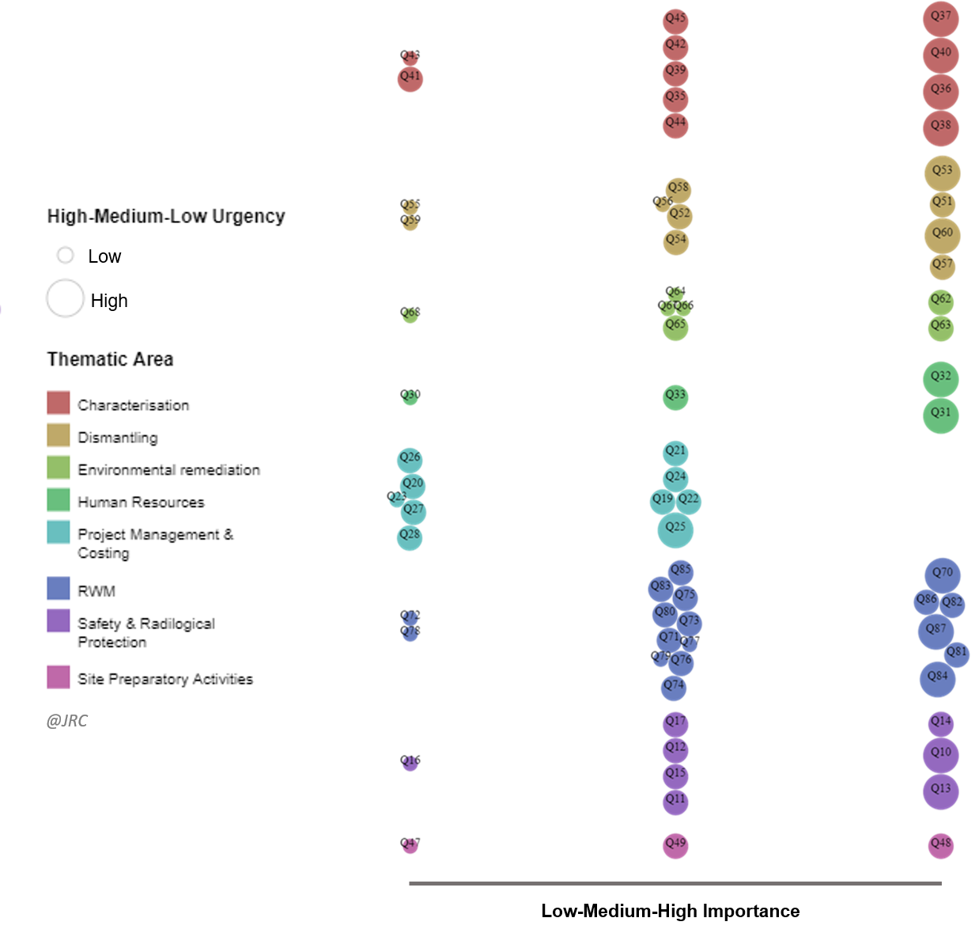

Figure 4‑2. Infographic Weighted-Population

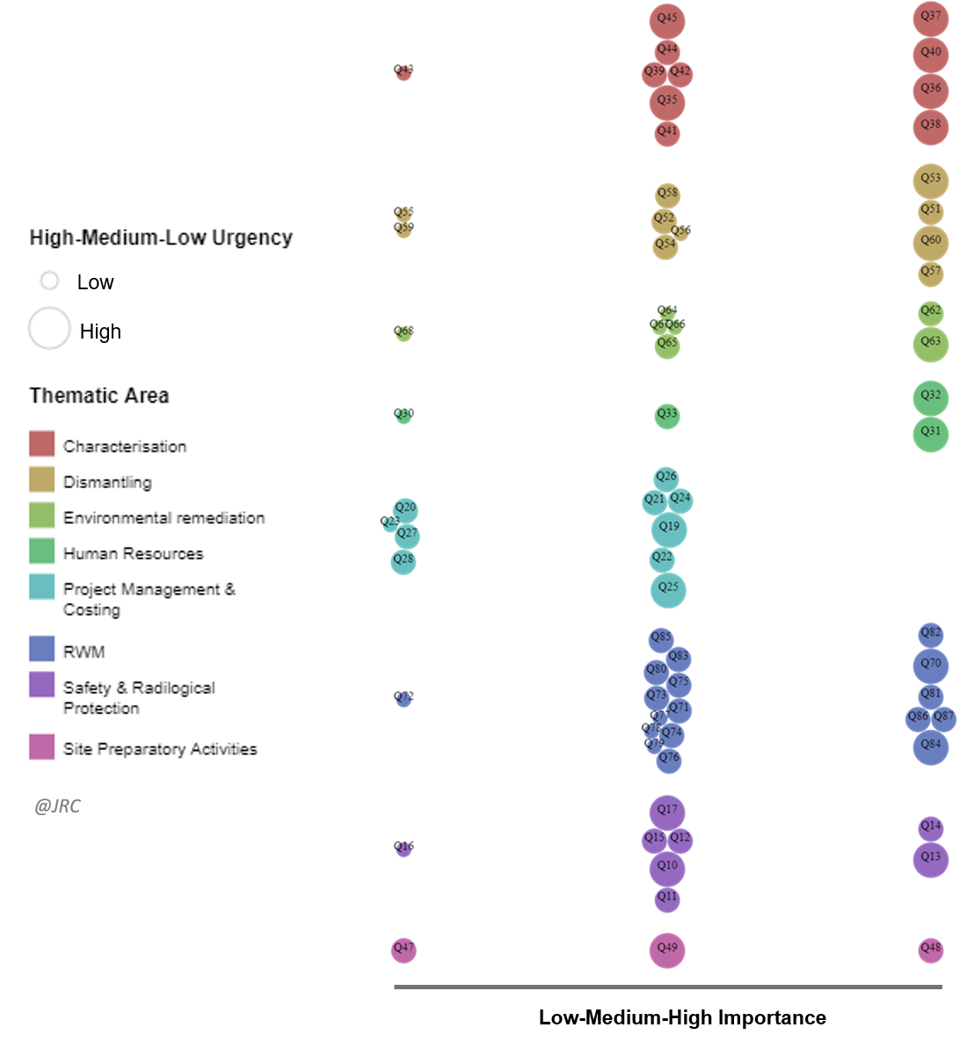

Figure 4‑3. Infographic Weighted-All

Figure 4‑4. Global survey comparison _ Unweighted - Weighted Population – Weighted All

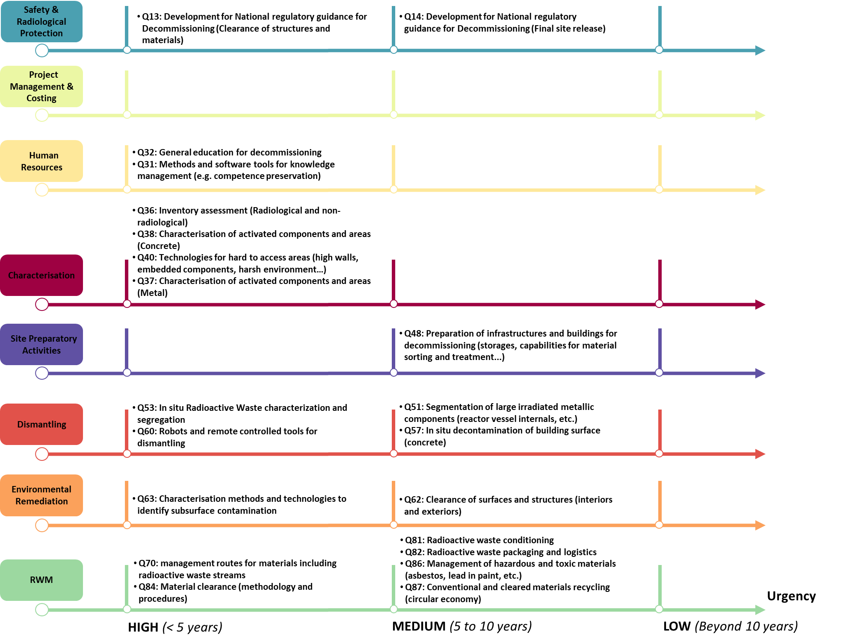

Figure 4‑5. Weighted-All (HIGH priorities for Importance) _ Urgency Priorities

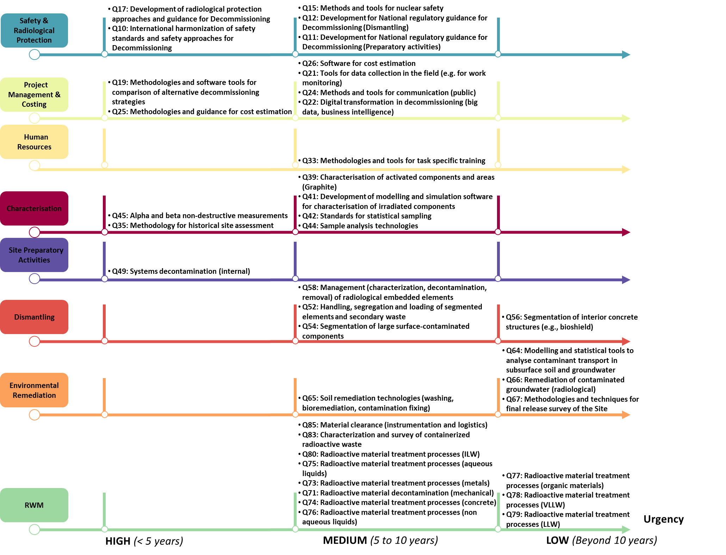

Figure 4‑6. Weighted-All (MEDIUM priorities for Importance) _ Urgency Priorities

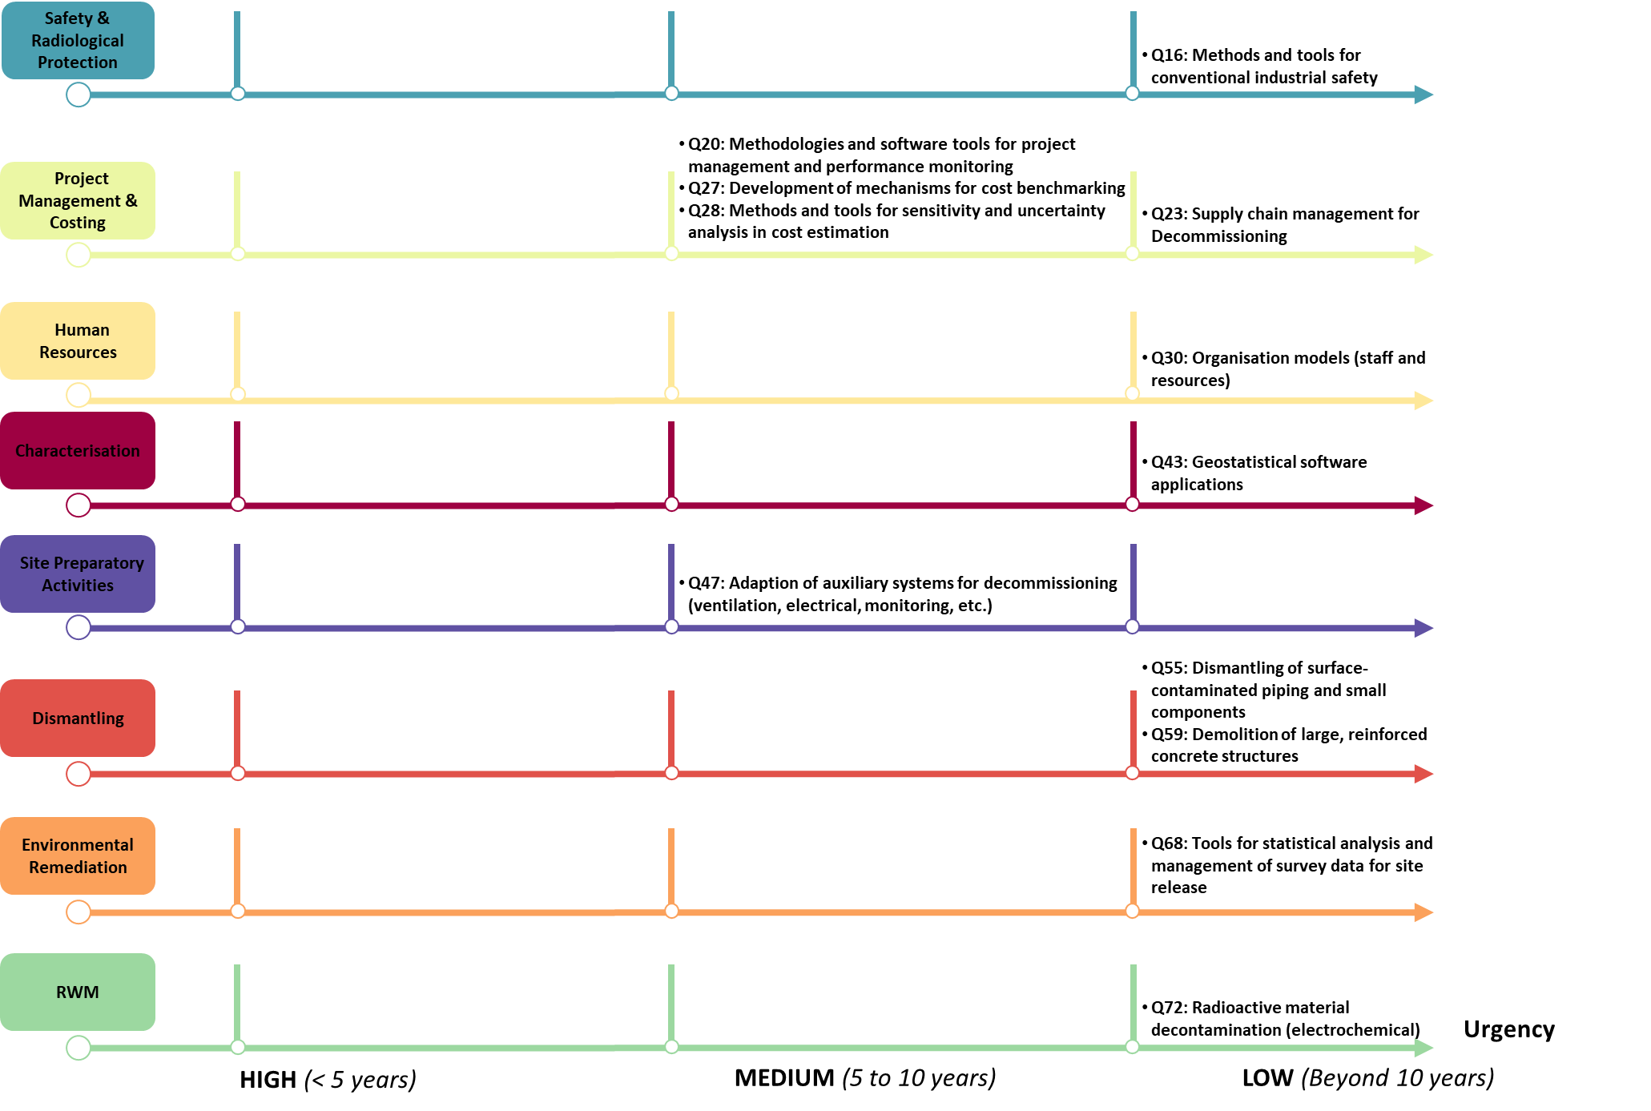

Figure 4‑7. Weighted-All (LOW priorities for Importance) _ Urgency Priorities

**Analysis by Region & Country**

The general trend of the answers is confirmed in the comparison of the Weighted-Population and Weighted-all data even if some changes of priorities is noted when all the weighting factors are considered.

For the General Thematic areas (see Figure 3‑6): “Characterisation” and “RWM” are considered as showing top scored needs for research in terms of importance and urgency by most of the Countries. Only Finland and Japan considered “Project Management & Costing” as showing top important needs .

Analysis of results shows a high consensus on needs for research in following sub thematic areas:

* Q36 “Inventory assessment (Radiological and non-radiological)”
* Q40 “Technologies for hard to access areas (high walls, embedded components, harsh environment…)”
* Q53 “In situ Radioactive Waste characterization and segregation”
* Q60 “Robots and remote controlled tools for dismantling”
* Q70 “Management routes for materials including radioactive waste streams”
* Q84 “Material clearance (methodology and procedures)”
* Q32 “General education for decommissioning”
* Q13 “Development for National regulatory guidance for Decommissioning (Clearance of structures and materials)”.

Some specific priorities have been also highlighted by some specific Countries in specific sub-thematic areas like Q81 “Radioactive waste conditioning” by UK and Q63 “Characterisation methods and technologies to identify subsurface contamination” by Finland, France and Italy.

**Analysis by Type of Organisation**

For the General Thematic areas (see Figure 3 20): here too, “Characterisation” and “RWM” are considered as showing top scored needs for research in terms of for importance and urgency by the most of the Type of Organisation. Only TSO considered “Project Management & Costing” and “human Resources” as showing top important needs and Regulator considered “Safety & Radiological Protection” with more important needs for Research than “RWM”

The general trend of the answers is confirmed in the comparison of the Weighted-Population and Weighted-all data even if some changes of priorities is noted when all the weighting factors are considered.

Analysis of results for sub thematic areas shows a high consensus on needs for research in following sub thematic areas :

* Q36 “Inventory assessment (Radiological and non-radiological)”
* Q37 “Characterisation of activated components and areas (Metal)”
* Q38 “Characterisation of activated components and areas (Concrete)
* Q40 “Technologies for hard to access areas (high walls, embedded components, harsh environment…)”
* Q53 “In situ Radioactive Waste characterization and segregation”
* Q60 “Robots and remote controlled tools for dismantling”
* Q62 “Clearance of surfaces and structures (interiors and exteriors)” and Q63 “Characterisation methods and technologies to identify subsurface contamination”
* Q32 “General education for decommissioning”
* Q13 “Development for National regulatory guidance for Decommissioning (Clearance of structures and materials)”
* Q14 “Development for National regulatory guidance for Decommissioning (Final site release)”

Some specific priority needs have also been highlighted by some specific Organisations like in Q31 “Methods and software tools for knowledge management (e.g. competence preservation)” mainly by TSO and also by Operator and University, in Q49 “Systems decontamination (internal)” by International Organisation and WMO and in Q67 “Methodologies and techniques for final release survey of the Site” by the Regulator (even if with low urgency).

**Analysis by Status of Decommissioning Project**

The general trend of the answers is confirmed in the comparison of the Weighted-Population and Weighted-all data and no significant differences are present among the shape of distribution for the different Status of decommissioning project both in Importance and Urgency answers.

For the General Thematic areas (see Figure 3 28): “Characterisation” and “RWM” are considered as showing top scored needs for research in terms of importance and urgency by most of stakeholders with different Status of decommissioning project. Only for stakeholders with Planning Status “Project Management & Costing” has been considered as showing more important needs than “RWM”

Analysis of results for sub thematic areas shows global consensus on needs for research in following sub-thematic areas:

* Q36 “Inventory assessment (Radiological and non-radiological)”
* Q60 “Robots and remote controlled tools for dismantling”
* Q13 “Development for National regulatory guidance for Decommissioning (Clearance of structures and materials)”

Only for stakeholders with no project (Q31 and Q32) are considered with priority needs.

Some specific priorities have been also highlighted by some stakeholders with specific status of decommissioning project like sub-thematic related to Human Resources (Q31 “Methods and software tools for knowledge management (e.g. competence preservation)” and Q32 “General education for decommissioning”) and project management (Q24 “Methods and tools for communication (public)”) for none and sub thematic related to RWM (Q73 “Radioactive material treatment processes (metals)”, Q74 “Radioactive material treatment processes (concrete)” and Q75 “Radioactive material treatment processes (aqueous liquids)”) and Environmental remediation (Q64 “Modelling and statistical tools to analyse contaminant transport in subsurface soil and groundwater”, Q65 “Soil remediation technologies (washing, bioremediation, contamination fixing)” and Q66 ”Remediation of contaminated groundwater (radiological)” for completed-near completed status.

**Analysis by Type of Facility**

The general trend of the answers is confirmed in the comparison of the Weighted-Population and Weighted-all data and no significant differences are present among the shape of distribution for the different Type of Facility both in Importance and Urgency answers.

For the General Thematic areas (see Figure 3‑23): “Characterisation” and “RWM” are considered as showing top scored needs for research in terms of importance and urgency by the most of the Type of Facility. Only for stakeholders with Power Reactor “Project Management & Costing” has been considered with more important needs than “RWM” and “Characterisation”.

Analysis of results for sub thematic areas shows a global consensus on needs for research in following sub thematic areas:

* Q36 “Inventory assessment (Radiological and non-radiological)”
* Q40 “Technologies for hard to access areas (high walls, embedded components, harsh environment…)”
* Q53 “In situ Radioactive Waste characterization and segregation”
* Q60 “Robots and remote controlled tools for dismantling”
* Q70 “Management routes for materials including radioactive waste streams”

Some specific priorities have been also highlighted by some specific Type of Facility like: Q39 “Characterisation of activated components and areas (Graphite)”, Q45 “Alpha and beta non-destructive measurements” and Q21 “Tools for data collection in the field (e.g. for work monitoring)” by Research Reactor, Q51 “Segmentation of large irradiated metallic components (reactor vessel internals, etc.)” and Q82 “Radioactive waste packaging and logistics” by Power Reactor, Q65 “Soil remediation technologies (washing, bioremediation, contamination fixing)”, Q67 “Methodologies and techniques for final release survey of the Site” and Q86 “Management of hazardous and toxic materials (asbestos, lead in paint, etc.)” by Fuel Cycle Facility and Q10 “International harmonization of safety standards and safety approaches for Decommissioning”, Q14 “Development for National regulatory guidance for Decommissioning (Final site release)” and Q17 “Development of radiological protection approaches and guidance for Decommissioning” by Other.

# ANNEX I – Additional Graphs

**REGION & COUNTRY**

**Weighted-All**

**Weighted-Population**

|  |  |
| --- | --- |
|  |  |

Figure 0‑1. Weighted Population (left) Weighted-All (right) _ Technical Areas - EU Countries

|  |  |  |  |
| --- | --- | --- | --- |
| |  |  | | --- | --- | | **Weighted-Population**  **Weighted-All** |  | |  |

Figure 0‑2. Weighted-Population (left) and Weighted-All (right)_ Non-Technical Areas - EU Countries

|  |  |
| --- | --- |
| **Weighted-Population**  **Weighted-All** |  |

Figure 0‑3. Weighted-Population (left) and Weighted-All (right) _ Technical Areas - Other Countries

|  |  |
| --- | --- |
| **Weighted-Population**  **Weighted-All** |  |

Figure 0‑4. Weighted-Population (left) and Weighted-All (right) _ Non-Technical Areas - Other Countries

**TYPE OF ORGANISATION**

|  |  |
| --- | --- |
| **Weighted-All**  **Weighted-Population** |  |

Figure 0‑5. Weighted Population (left) Weighted-All (right) _ Technical Areas – Type of Organisation

|  |  |
| --- | --- |
| **Weighted-Population**  **Weighted-All** |  |

Figure 0‑6. Weighted-Population (left) and Weighted-All (right)_ Non-Technical Areas – Type of Organisation

**STATUS OF DECOMMISSIONING PROJECT**

|  |  |
| --- | --- |
| **Weighted-Population** | **Weighted-All** |

Figure 0‑7. Status of decommissioning Non-technical Sub thematic areas, in Weighted-Population (left) and Weighted-All (right)

|  |  |
| --- | --- |
| **Weighted-Population** | **Weighted-All** |

Figure 0‑8. Status of decommissioning Technical Sub thematic areas, in Weighted-Population (left) and Weighted-All (right)

**TYPE OF FACILITY**

|  |  |
| --- | --- |
| **Weighted-Population** | **Weighted-All** |

Figure 0‑9. Type of facility Non-Technical Sub thematic areas, in Weighted-Population (left) and Weighted-All (right)

|  |  |
| --- | --- |
| **Weighted-Population** | **Weighted-All** |

Figure 0‑10. Type of facility Technical Sub thematic areas, in Weighted-Population (left) and Weighted-All (right)

# ANNEX II – Completed working file

**STAKEHOLDER TYPE**

**Partner 1**



**Partner 2**



**Partner 3**



**Partner 4**



**Partner 5**



**Partner 6**



**Partner 7**



**STATUS OF DECOMMISSIONING PROJECT**



**REGION**



# ANNEX III – Ranking of sub-thematic areas

Table 1- Annex III. Ranking of sub-thematic areas for “Weighted All Survey” in terms of importance of needs

| **Rank** | **Sub-thematic area** | **Percent Top 2 Boxes**  ***“Weighted-All Survey”***  **Importance** |
| --- | --- | --- |
| **1** | Q36. Inventory assessment (Radiological and non-radiological) | 68,3 |
| **2** | Q53. In situ Radioactive Waste characterization and segregation | 64,3 |
| **3** | Q60. Robots and remote controlled tools for dismantling | 62,4 |
| **4** | Q38. Characterisation of activated components and areas (Concrete) | 60,5 |
| **5** | Q40. Technologies for hard to access areas (high walls, embedded components, harsh environment…) | 59,4 |
| **6** | Q37. Characterisation of activated components and areas (Metal) | 58,2 |
| **7** | Q70. Management routes for materials including radioactive waste streams | 58,1 |
| **8** | Q13. Development for National regulatory guidance for Decommissioning (Clearance of structures and materials) | 57,0 |
| **9** | Q62. Clearance of surfaces and structures (interiors and exteriors) | 56,6 |
| **10** | Q63. Characterisation methods and technologies to identify subsurface contamination | 56,1 |
| **11** | Q84. Material clearance (methodology and procedures) | 55,3 |
| **12** | Q14. Development for National regulatory guidance for Decommissioning (Final site release) | 55,0 |
| **13** | Q32. General education for decommissioning | 54,5 |
| **14** | Q51. Segmentation of large irradiated metallic components (reactor vessel internals, etc.) | 53,9 |
| **15** | Q31. Methods and software tools for knowledge management (e.g. competence preservation) | 52,9 |
| **16** | Q86. Management of hazardous and toxic materials (asbestos, lead in paint, etc.) | 52,7 |
| **17** | Q87. Conventional and cleared materials recycling (circular economy) | 52,3 |
| **18** | Q57. In situ decontamination of building surface (concrete) | 52,0 |
| **19** | Q82. Radioactive waste packaging and logistics | 51,9 |
| **20** | Q81. Radioactive waste conditioning | 51,9 |
| **21** | Q48. Preparation of infrastructures and buildings for decommissioning (storages, capabilities for material sorting and treatment...) | 50,2 |
| **22** | Q10. International harmonization of safety standards and safety approaches for Decommissioning | 49,7 |
| **23** | Q67. Methodologies and techniques for final release survey of the Site | 49,2 |
| **24** | Q83. Characterization and survey of containerized radioactive waste | 49,2 |
| **25** | Q49. Systems decontamination (internal) | 49,1 |
| **26** | Q80. Radioactive material treatment processes (ILW) | 48,5 |
| **27** | Q58. Management (characterization, decontamination, removal) of radiological embedded elements | 48,4 |
| **28** | Q54. Segmentation of large surface-contaminated components | 48,4 |
| **29** | Q35. Methodology for historical site assessment | 48,4 |
| **30** | Q45. Alpha and beta non-destructive measurements | 48,3 |
| **31** | Q52. Handling, segregation and loading of segmented elements and secondary waste | 48,3 |
| **32** | Q25. Methodologies and guidance for cost estimation | 47,3 |
| **33** | Q15. Methods and tools for nuclear safety | 47,1 |
| **34** | Q17. Development of radiological protection approaches and guidance for Decommissioning | 46,6 |
| **35** | Q85. Material clearance (instrumentation and logistics) | 46,3 |
| **36** | Q73. Radioactive material treatment processes (metals) | 46,2 |
| **37** | Q21. Tools for data collection in the field (e.g. for work monitoring) | 45,6 |
| **38** | Q56. Segmentation of interior concrete structures (e.g., bioshield) | 45,4 |
| **39** | Q19. Methodologies and software tools for comparison of alternative decommissioning strategies | 45,2 |
| **40** | Q33. Methodologies and tools for task specific training | 45,0 |
| **41** | Q74. Radioactive material treatment processes (concrete) | 44,6 |
| **42** | Q11. Development for National regulatory guidance for Decommissioning (Preparatory activities) | 44,4 |
| **43** | Q12. Development for National regulatory guidance for Decommissioning (Dismantling) | 44,1 |
| **44** | Q39. Characterisation of activated components and areas (Graphite) | 44,0 |
| **45** | Q71. Radioactive material decontamination (mechanical) | 43,9 |
| **46** | Q42. Standards for statistical sampling | 43,6 |
| **47** | Q44. Sample analysis technologies | 43,2 |
| **48** | Q75. Radioactive material treatment processes (aqueous liquids) | 43,1 |
| **49** | Q76. Radioactive material treatment processes (non aqueous liquids) | 43,1 |
| **50** | Q24. Methods and tools for communication (public) | 43,0 |
| **51** | Q65. Soil remediation technologies (washing, bioremediation, contamination fixing) | 42,9 |
| **52** | Q64. Modelling and statistical tools to analyse contaminant transport in subsurface soil and groundwater | 42,0 |
| **53** | Q77. Radioactive material treatment processes (organic materials) | 41,4 |
| **54** | Q66. Remediation of contaminated groundwater (radiological) | 41,1 |
| **55** | Q22. Digital transformation in decommissioning (big data, business intelligence) | 40,9 |
| **56** | Q79. Radioactive material treatment processes (LLW) | 40,9 |
| **57** | Q26. Software for cost estimation | 40,6 |
| **58** | Q41. Development of modelling and simulation software for characterisation of irradiated components | 40,3 |
| **59** | Q78. Radioactive material treatment processes (VLLW) | 40,1 |
| **60** | Q28. Methods and tools for sensitivity and uncertainty analysis in cost estimation | 39,4 |
| **61** | Q68. Tools for statistical analysis and management of survey data for site release | 38,8 |
| **62** | Q47. Adaption of auxiliary systems for decommissioning (ventilation, electrical, monitoring, etc.) | 38,8 |
| **63** | Q20. Methodologies and software tools for project management and performance monitoring | 38,3 |
| **64** | Q23. Supply chain management for Decommissioning | 38,0 |
| **65** | Q27. Development of mechanisms for cost benchmarking | 37,9 |
| **66** | Q72. Radioactive material decontamination (electrochemical) | 37,0 |
| **67** | Q55. Dismantling of surface-contaminated piping and small components | 36,1 |
| **68** | Q30. Organisation models (staff and resources) | 35,4 |
| **69** | Q16. Methods and tools for conventional industrial safety | 34,7 |
| **70** | Q59. Demolition of large, reinforced concrete structures | 31,9 |
| **71** | Q43. Geostatistical software applications | 23,8 |

Table 2- Annex III. Ranking of sub-thematic areas for “Weighted All Survey” in terms of urgency of needs

| **Rank** | **Sub-thematic area** | **Percent Top 2 Boxes**  ***“Weighted-All Survey”***  **Urgency** |
| --- | --- | --- |
| **1** | Q36. Inventory assessment (Radiological and non-radiological) | 54,5 |
| **2** | Q53. In situ Radioactive Waste characterization and segregation | 50,7 |
| **3** | Q32. General education for decommissioning | 49,1 |
| **4** | Q13. Development for National regulatory guidance for Decommissioning (Clearance of structures and materials) | 46,1 |
| **5** | Q38. Characterisation of activated components and areas (Concrete) | 44,5 |
| **6** | Q70. Management routes for materials including radioactive waste streams | 43,6 |
| **7** | Q37. Characterisation of activated components and areas (Metal) | 43,5 |
| **8** | Q40. Technologies for hard to access areas (high walls, embedded components, harsh environment…) | 43,1 |
| **9** | Q60. Robots and remote controlled tools for dismantling | 43,1 |
| **10** | Q84. Material clearance (methodology and procedures) | 43,0 |
| **11** | Q31. Methods and software tools for knowledge management (e.g. competence preservation) | 42,3 |
| **12** | Q25. Methodologies and guidance for cost estimation | 42,1 |
| **13** | Q10. International harmonization of safety standards and safety approaches for Decommissioning | 41,6 |
| **14** | Q45. Alpha and beta non-destructive measurements | 41,4 |
| **15** | Q63. Characterisation methods and technologies to identify subsurface contamination | 40,6 |
| **16** | Q19. Methodologies and software tools for comparison of alternative decommissioning strategies | 40,4 |
| **17** | Q35. Methodology for historical site assessment | 40,3 |
| **18** | Q49. Systems decontamination (internal) | 40,0 |
| **19** | Q33. Methodologies and tools for task specific training | 39,7 |
| **20** | Q11. Development for National regulatory guidance for Decommissioning (Preparatory activities) | 39,5 |
| **21** | Q87. Conventional and cleared materials recycling (circular economy) | 39,4 |
| **22** | Q51. Segmentation of large irradiated metallic components (reactor vessel internals, etc.) | 39,1 |
| **23** | Q42. Standards for statistical sampling | 38,9 |
| **24** | Q86. Management of hazardous and toxic materials (asbestos, lead in paint, etc.) | 38,8 |
| **25** | Q17. Development of radiological protection approaches and guidance for Decommissioning | 38,1 |
| **26** | Q24. Methods and tools for communication (public) | 38,0 |
| **27** | Q81. Radioactive waste conditioning | 38,0 |
| **28** | Q82. Radioactive waste packaging and logistics | 37,4 |
| **29** | Q39. Characterisation of activated components and areas (Graphite) | 36,9 |
| **30** | Q83. Characterization and survey of containerized radioactive waste | 35,9 |
| **31** | Q62. Clearance of surfaces and structures (interiors and exteriors) | 35,7 |
| **32** | Q57. In situ decontamination of building surface (concrete) | 35,0 |
| **33** | Q21. Tools for data collection in the field (e.g. for work monitoring) | 34,5 |
| **34** | Q12. Development for National regulatory guidance for Decommissioning (Dismantling) | 34,3 |
| **35** | Q15. Methods and tools for nuclear safety | 34,2 |
| **36** | Q52. Handling, segregation and loading of segmented elements and secondary waste | 34,2 |
| **37** | Q85. Material clearance (instrumentation and logistics) | 34,2 |
| **38** | Q41. Development of modelling and simulation software for characterisation of irradiated components | 33,8 |
| **39** | Q73. Radioactive material treatment processes (metals) | 33,8 |
| **40** | Q28. Methods and tools for sensitivity and uncertainty analysis in cost estimation | 33,6 |
| **41** | Q20. Methodologies and software tools for project management and performance monitoring | 33,6 |
| **42** | Q80. Radioactive material treatment processes (ILW) | 33,2 |
| **43** | Q71. Radioactive material decontamination (mechanical) | 33,0 |
| **44** | Q44. Sample analysis technologies | 32,9 |
| **45** | Q58. Management (characterization, decontamination, removal) of radiological embedded elements | 32,7 |
| **46** | Q14. Development for National regulatory guidance for Decommissioning (Final site release) | 32,4 |
| **47** | Q26. Software for cost estimation | 32,3 |
| **48** | Q22. Digital transformation in decommissioning (big data, business intelligence) | 32,2 |
| **49** | Q27. Development of mechanisms for cost benchmarking | 32,1 |
| **50** | Q54. Segmentation of large surface-contaminated components | 31,9 |
| **51** | Q48. Preparation of infrastructures and buildings for decommissioning (storages, capabilities for material sorting and treatment...) | 31,7 |
| **52** | Q75. Radioactive material treatment processes (aqueous liquids) | 31,6 |
| **53** | Q65. Soil remediation technologies (washing, bioremediation, contamination fixing) | 31,3 |
| **54** | Q76. Radioactive material treatment processes (non aqueous liquids) | 31,3 |
| **55** | Q74. Radioactive material treatment processes (concrete) | 31,1 |
| **56** | Q47. Adaption of auxiliary systems for decommissioning (ventilation, electrical, monitoring, etc.) | 30,0 |
| **57** | Q30. Organisation models (staff and resources) | 29,6 |
| **58** | Q23. Supply chain management for Decommissioning | 29,1 |
| **59** | Q66. Remediation of contaminated groundwater (radiological) | 28,9 |
| **60** | Q77. Radioactive material treatment processes (organic materials) | 28,8 |
| **61** | Q16. Methods and tools for conventional industrial safety | 28,5 |
| **62** | Q78. Radioactive material treatment processes (VLLW) | 28,4 |
| **63** | Q79. Radioactive material treatment processes (LLW) | 28,4 |
| **64** | Q56. Segmentation of interior concrete structures (e.g., bioshield) | 28,3 |
| **65** | Q64. Modelling and statistical tools to analyse contaminant transport in subsurface soil and groundwater | 28,1 |
| **66** | Q72. Radioactive material decontamination (electrochemical) | 28,0 |
| **67** | Q67. Methodologies and techniques for final release survey of the Site | 27,9 |
| **68** | Q55. Dismantling of surface-contaminated piping and small components | 27,3 |
| **69** | Q59. Demolition of large, reinforced concrete structures | 21,3 |
| **70** | Q43. Geostatistical software applications | 20,5 |
| **71** | Q68. Tools for statistical analysis and management of survey data for site release | 20,4 |

Table 3- Annex III. Ranking of sub-thematic areas for “Weighted Population Survey” in terms of importance of needs

| **Rank** | **Sub-thematic area** | **Percent Top 2 Boxes**  ***“Weighted-Population Survey”***  **Importance** |
| --- | --- | --- |
| **1** | Q36. Inventory assessment (Radiological and non-radiological) | 67,3 |
| **2** | Q53. In situ Radioactive Waste characterization and segregation | 63,9 |
| **3** | Q60. Robots and remote controlled tools for dismantling | 61,6 |
| **4** | Q38. Characterisation of activated components and areas (Concrete) | 59,3 |
| **5** | Q40. Technologies for hard to access areas (high walls, embedded components, harsh environment…) | 58,8 |
| **6** | Q37. Characterisation of activated components and areas (Metal) | 57,7 |
| **7** | Q70. Management routes for materials including radioactive waste streams | 57,2 |
| **8** | Q13. Development for National regulatory guidance for Decommissioning (Clearance of structures and materials) | 56,3 |
| **9** | Q32. General education for decommissioning | 55,4 |
| **10** | Q62. Clearance of surfaces and structures (interiors and exteriors) | 55,3 |
| **11** | Q63. Characterisation methods and technologies to identify subsurface contamination | 55,0 |
| **12** | Q14. Development for National regulatory guidance for Decommissioning (Final site release) | 54,2 |
| **13** | Q84. Material clearance (methodology and procedures) | 54,0 |
| **14** | Q51. Segmentation of large irradiated metallic components (reactor vessel internals, etc.) | 53,6 |
| **15** | Q31. Methods and software tools for knowledge management (e.g. competence preservation) | 52,7 |
| **16** | Q86. Management of hazardous and toxic materials (asbestos, lead in paint, etc.) | 52,6 |
| **17** | Q87. Conventional and cleared materials recycling (circular economy) | 52,5 |
| **18** | Q82. Radioactive waste packaging and logistics | 51,8 |
| **19** | Q57. In situ decontamination of building surface (concrete) | 51,0 |
| **20** | Q48. Preparation of infrastructures and buildings for decommissioning (storages, capabilities for material sorting and treatment...) | 50,6 |
| **21** | Q81. Radioactive waste conditioning | 50,5 |
| **22** | Q10. International harmonization of safety standards and safety approaches for Decommissioning | 50,0 |
| **23** | Q49. Systems decontamination (internal) | 49,1 |
| **24** | Q67. Methodologies and techniques for final release survey of the Site | 49,1 |
| **25** | Q52. Handling, segregation and loading of segmented elements and secondary waste | 48,6 |
| **26** | Q83. Characterization and survey of containerized radioactive waste | 48,5 |
| **27** | Q15. Methods and tools for nuclear safety | 48,3 |
| **28** | Q35. Methodology for historical site assessment | 48,2 |
| **29** | Q80. Radioactive material treatment processes (ILW) | 48,1 |
| **30** | Q17. Development of radiological protection approaches and guidance for Decommissioning | 47,7 |
| **31** | Q54. Segmentation of large surface-contaminated components | 47,3 |
| **32** | Q58. Management (characterization, decontamination, removal) of radiological embedded elements | 47,0 |
| **33** | Q45. Alpha and beta non-destructive measurements | 46,3 |
| **34** | Q25. Methodologies and guidance for cost estimation | 46,2 |
| **35** | Q85. Material clearance (instrumentation and logistics) | 45,5 |
| **36** | Q73. Radioactive material treatment processes (metals) | 45,2 |
| **37** | Q33. Methodologies and tools for task specific training | 45,2 |
| **38** | Q56. Segmentation of interior concrete structures (e.g., bioshield) | 45,0 |
| **39** | Q21. Tools for data collection in the field (e.g. for work monitoring) | 44,8 |
| **40** | Q11. Development for National regulatory guidance for Decommissioning (Preparatory activities) | 44,8 |
| **41** | Q24. Methods and tools for communication (public) | 44,1 |
| **42** | Q19. Methodologies and software tools for comparison of alternative decommissioning strategies | 43,9 |
| **43** | Q12. Development for National regulatory guidance for Decommissioning (Dismantling) | 43,9 |
| **44** | Q39. Characterisation of activated components and areas (Graphite) | 43,7 |
| **45** | Q74. Radioactive material treatment processes (concrete) | 43,5 |
| **46** | Q71. Radioactive material decontamination (mechanical) | 43,3 |
| **47** | Q75. Radioactive material treatment processes (aqueous liquids) | 42,8 |
| **48** | Q65. Soil remediation technologies (washing, bioremediation, contamination fixing) | 42,8 |
| **49** | Q76. Radioactive material treatment processes (non aqueous liquids) | 42,4 |
| **50** | Q42. Standards for statistical sampling | 42,2 |
| **51** | Q44. Sample analysis technologies | 41,8 |
| **52** | Q64. Modelling and statistical tools to analyse contaminant transport in subsurface soil and groundwater | 41,8 |
| **53** | Q66. Remediation of contaminated groundwater (radiological) | 41,7 |
| **54** | Q77. Radioactive material treatment processes (organic materials) | 41,0 |
| **55** | Q79. Radioactive material treatment processes (LLW) | 40,3 |
| **56** | Q22. Digital transformation in decommissioning (big data, business intelligence) | 40,3 |
| **57** | Q41. Development of modelling and simulation software for characterisation of irradiated components | 39,9 |
| **58** | Q78. Radioactive material treatment processes (VLLW) | 39,6 |
| **59** | Q26. Software for cost estimation | 39,3 |
| **60** | Q47. Adaption of auxiliary systems for decommissioning (ventilation, electrical, monitoring, etc.) | 38,8 |
| **61** | Q68. Tools for statistical analysis and management of survey data for site release | 38,7 |
| **62** | Q23. Supply chain management for Decommissioning | 38,7 |
| **63** | Q28. Methods and tools for sensitivity and uncertainty analysis in cost estimation | 38,2 |
| **64** | Q27. Development of mechanisms for cost benchmarking | 37,8 |
| **65** | Q20. Methodologies and software tools for project management and performance monitoring | 37,3 |
| **66** | Q72. Radioactive material decontamination (electrochemical) | 36,5 |
| **67** | Q55. Dismantling of surface-contaminated piping and small components | 35,4 |
| **68** | Q30. Organisation models (staff and resources) | 35,1 |
| **69** | Q16. Methods and tools for conventional industrial safety | 35,0 |
| **70** | Q59. Demolition of large, reinforced concrete structures | 31,3 |
| **71** | Q43. Geostatistical software applications | 23,0 |

**Table 3- Annex 3.** Ranking of sub-thematic areas for “Weighted Population Survey” in terms of urgency of needs

| **Rank** | **Sub-thematic area** | **Percent Top 2 Boxes**  ***“Weighted-Population Survey”***  **Urgency** |
| --- | --- | --- |
| **1** | Q36. Inventory assessment (Radiological and non-radiological) | 52,8 |
| **2** | Q53. In situ Radioactive Waste characterization and segregation | 50,2 |
| **3** | Q32. General education for decommissioning | 49,7 |
| **4** | Q13. Development for National regulatory guidance for Decommissioning (Clearance of structures and materials) | 45,9 |
| **5** | Q38. Characterisation of activated components and areas (Concrete) | 43,5 |
| **6** | Q70. Management routes for materials including radioactive waste streams | 43,0 |
| **7** | Q60. Robots and remote controlled tools for dismantling | 42,7 |
| **8** | Q40. Technologies for hard to access areas (high walls, embedded components, harsh environment…) | 42,7 |
| **9** | Q31. Methods and software tools for knowledge management (e.g. competence preservation) | 42,7 |
| **10** | Q37. Characterisation of activated components and areas (Metal) | 42,7 |
| **11** | Q10. International harmonization of safety standards and safety approaches for Decommissioning | 42,1 |
| **12** | Q84. Material clearance (methodology and procedures) | 41,8 |
| **13** | Q25. Methodologies and guidance for cost estimation | 41,2 |
| **14** | Q87. Conventional and cleared materials recycling (circular economy) | 40,2 |
| **15** | Q35. Methodology for historical site assessment | 39,9 |
| **16** | Q49. Systems decontamination (internal) | 39,8 |
| **17** | Q63. Characterisation methods and technologies to identify subsurface contamination | 39,7 |
| **18** | Q45. Alpha and beta non-destructive measurements | 39,6 |
| **19** | Q11. Development for National regulatory guidance for Decommissioning (Preparatory activities) | 39,5 |
| **20** | Q86. Management of hazardous and toxic materials (asbestos, lead in paint, etc.) | 39,5 |
| **21** | Q33. Methodologies and tools for task specific training | 39,4 |
| **22** | Q51. Segmentation of large irradiated metallic components (reactor vessel internals, etc.) | 39,2 |
| **23** | Q19. Methodologies and software tools for comparison of alternative decommissioning strategies | 38,9 |
| **24** | Q24. Methods and tools for communication (public) | 38,4 |
| **25** | Q17. Development of radiological protection approaches and guidance for Decommissioning | 37,7 |
| **26** | Q82. Radioactive waste packaging and logistics | 37,6 |
| **27** | Q42. Standards for statistical sampling | 37,3 |
| **28** | Q81. Radioactive waste conditioning | 36,9 |
| **29** | Q39. Characterisation of activated components and areas (Graphite) | 36,8 |
| **30** | Q83. Characterization and survey of containerized radioactive waste | 36,1 |
| **31** | Q62. Clearance of surfaces and structures (interiors and exteriors) | 35,5 |
| **32** | Q15. Methods and tools for nuclear safety | 35,0 |
| **33** | Q12. Development for National regulatory guidance for Decommissioning (Dismantling) | 34,6 |
| **34** | Q52. Handling, segregation and loading of segmented elements and secondary waste | 34,6 |
| **35** | Q57. In situ decontamination of building surface (concrete) | 34,3 |
| **36** | Q41. Development of modelling and simulation software for characterisation of irradiated components | 33,7 |
| **37** | Q21. Tools for data collection in the field (e.g. for work monitoring) | 33,7 |
| **38** | Q80. Radioactive material treatment processes (ILW) | 33,5 |
| **39** | Q85. Material clearance (instrumentation and logistics) | 33,4 |
| **40** | Q73. Radioactive material treatment processes (metals) | 33,3 |
| **41** | Q71. Radioactive material decontamination (mechanical) | 33,2 |
| **42** | Q14. Development for National regulatory guidance for Decommissioning (Final site release) | 32,9 |
| **43** | Q58. Management (characterization, decontamination, removal) of radiological embedded elements | 32,5 |
| **44** | Q28. Methods and tools for sensitivity and uncertainty analysis in cost estimation | 32,4 |
| **45** | Q20. Methodologies and software tools for project management and performance monitoring | 32,0 |
| **46** | Q22. Digital transformation in decommissioning (big data, business intelligence) | 31,8 |
| **47** | Q48. Preparation of infrastructures and buildings for decommissioning (storages, capabilities for material sorting and treatment...) | 31,8 |
| **48** | Q75. Radioactive material treatment processes (aqueous liquids) | 31,7 |
| **49** | Q27. Development of mechanisms for cost benchmarking | 31,7 |
| **50** | Q26. Software for cost estimation | 31,5 |
| **51** | Q44. Sample analysis technologies | 31,5 |
| **52** | Q76. Radioactive material treatment processes (non aqueous liquids) | 31,1 |
| **53** | Q65. Soil remediation technologies (washing, bioremediation, contamination fixing) | 31,1 |
| **54** | Q54. Segmentation of large surface-contaminated components | 31,1 |
| **55** | Q74. Radioactive material treatment processes (concrete) | 30,2 |
| **56** | Q66. Remediation of contaminated groundwater (radiological) | 29,7 |
| **57** | Q47. Adaption of auxiliary systems for decommissioning (ventilation, electrical, monitoring, etc.) | 29,4 |
| **58** | Q30. Organisation models (staff and resources) | 29,2 |
| **59** | Q23. Supply chain management for Decommissioning | 28,8 |
| **60** | Q64. Modelling and statistical tools to analyse contaminant transport in subsurface soil and groundwater | 28,8 |
| **61** | Q16. Methods and tools for conventional industrial safety | 28,5 |
| **62** | Q77. Radioactive material treatment processes (organic materials) | 28,4 |
| **63** | Q79. Radioactive material treatment processes (LLW) | 28,0 |
| **64** | Q67. Methodologies and techniques for final release survey of the Site | 27,9 |
| **65** | Q78. Radioactive material treatment processes (VLLW) | 27,8 |
| **66** | Q72. Radioactive material decontamination (electrochemical) | 27,6 |
| **67** | Q56. Segmentation of interior concrete structures (e.g., bioshield) | 27,5 |
| **68** | Q55. Dismantling of surface-contaminated piping and small components | 27,1 |
| **69** | Q59. Demolition of large, reinforced concrete structures | 21,4 |
| **70** | Q68. Tools for statistical analysis and management of survey data for site release | 20,0 |
| **71** | Q43. Geostatistical software applications | 19,6 |

1. Saaty TL (1980) The Analytic Hierarchy Process: Planning, Priority Setting, Resource Allocation. McGraw-Hill International Book Co., New York.
2. According to Saaty theory if CR ≤ 0,1 then the matrix and the relative comparisons are considered acceptable. When the value of CI exceeds a threshold equal to 10% of RI the deviation from the condition of consistency is considered unacceptable and therefore the judgments will have to be revised to increase their consistency and fall within the admissibility range.